**Team leader:**

Ben Zhang:          A00976551

**Team members:**

Andrew Main:     A00815430

Phat Le:               A01012144

Simon Shoban:    A00985653

Cameron Roberts:  A00966003

**Milestone 5 – Server Side Programming**

**Game Review 8™ Game Review Web System**

**COMP 1536 Group 6**

**Date: 04-12-2017**

**Table of Contents**

**1. User registration pg.4**

1.1 Successful registration pg.4

1.2 Unsuccessful registration pg.5

**2. User authentication pg.5**

**3. Server side function s pg.7**

**Appendix pg.10**

**Note we used .htaccess to have the server run our html files as php.**

**Links:**

1. **Sign up page**

http://students.bcitdev.com/A00966003/project/sign_up.html

1. **Game review page - FF15 to post comments**

http://students.bcitdev.com/A00966003/project/devices/console/ps4/console_review_FF15.html

**1.User registration:**

**1.1 Successful Registration:**

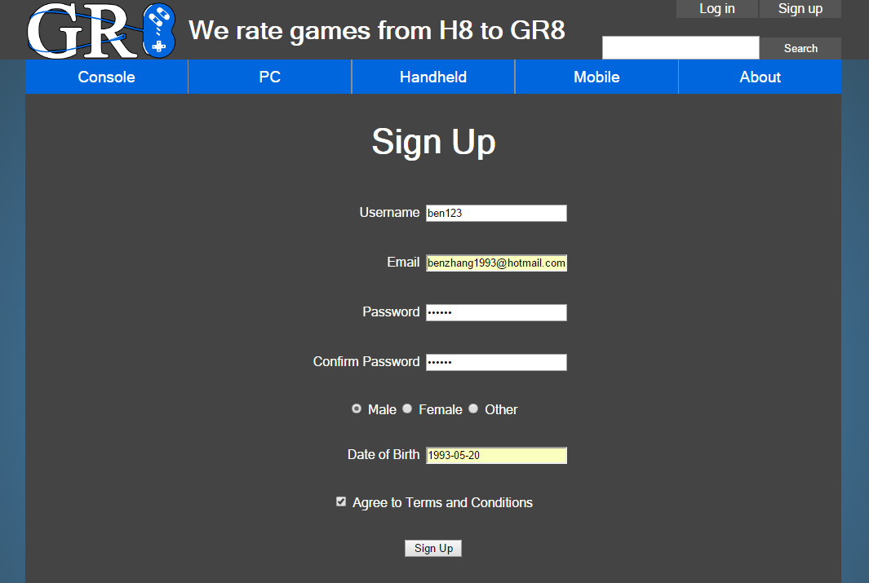

Users can sign up for accounts in the sign up page, they must follow the JavaScript form checks to be able to successfully send the info to register.php, which processes the user input and creates an account in the database.

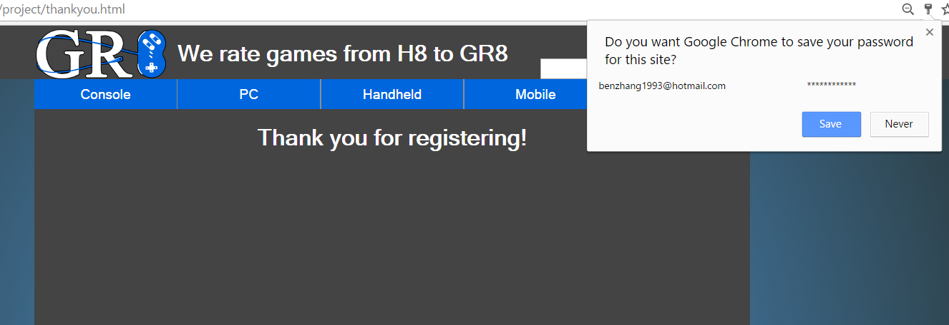

If registration is successful, register.php will redirect the user to the thankyou.html page.

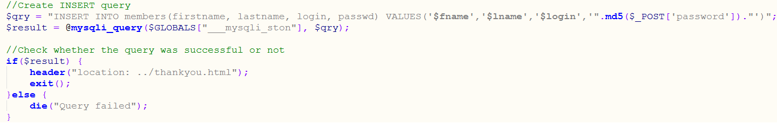

Code from reigster.php for successful redirection.

**1.2 Unsuccessful registration**



If registration fails, register.php redirects you back to the sign_up.html page, and it is reloaded with added php to display error messages.

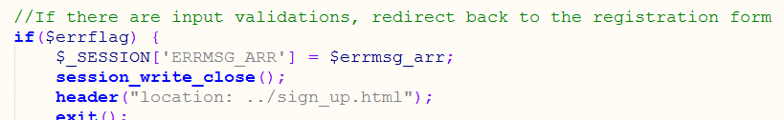

This is the redirection from register.php for unsuccessful sign ups.

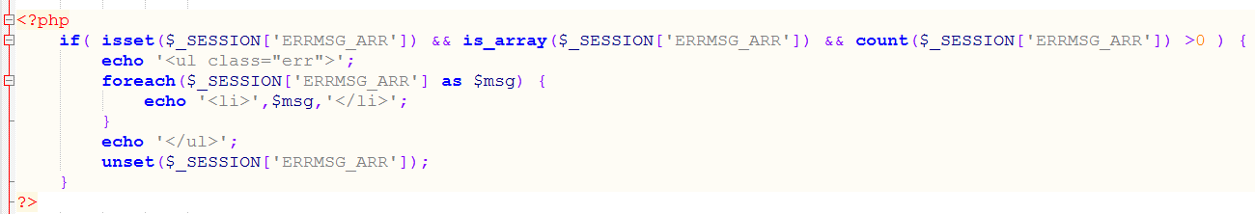

This is the embedded PHP code to display the error messages.

**2. User authentication**

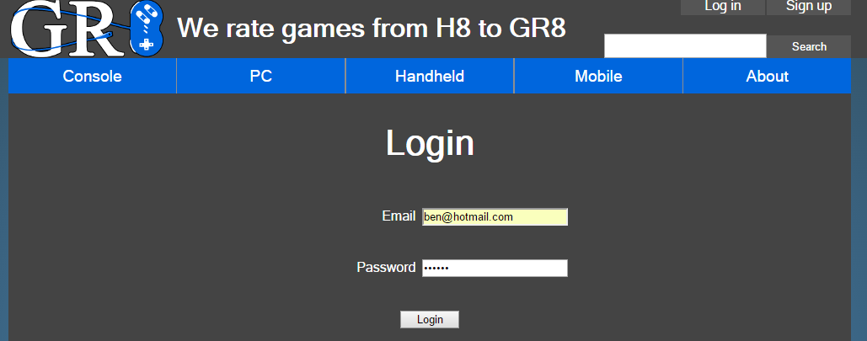

Users can login to their accounts after signing up by inputting their email and password, the info will be sent to login.php. The login.php will then verifies the login info. If it is successful it creates the session variables and redirects the user back to the index.html page. If login is unsuccessful the user will be redirected back to log_in.html and displays an error message..

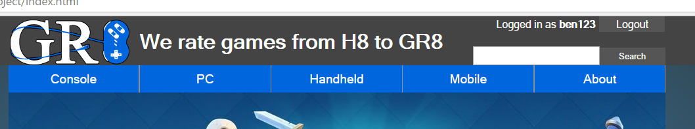

The username is displayed at top right when logged in.

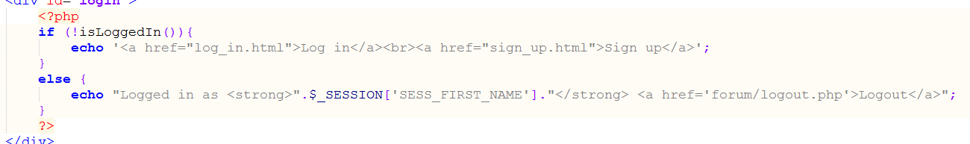

The embedded PHP to display the username depending on if the user is logged in or not. All pages include functions.php, which that contains the isLoggedIn() function.

After clicking logout, the user will be logged out and brought back to index.html.

**3. Server side function:**

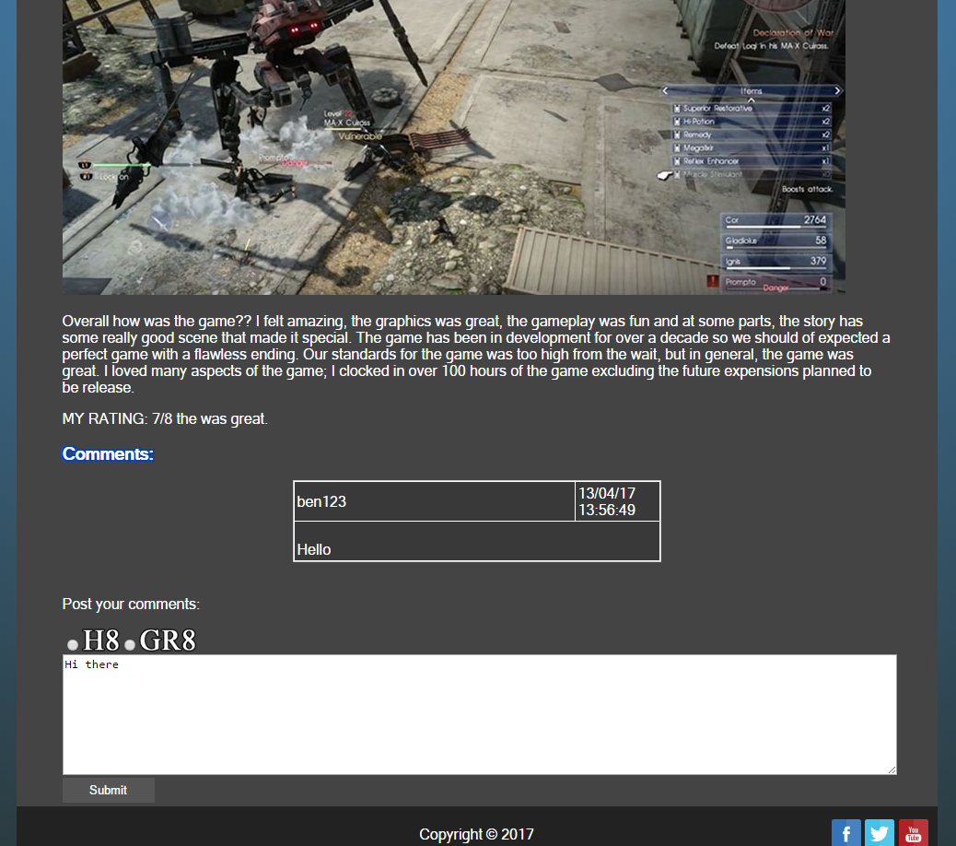

Users can post comments if they are logged in. they can enter their comment in the text field below the already posted comments. The form will be sent to add_response.php which will send the information to the responses table in the database.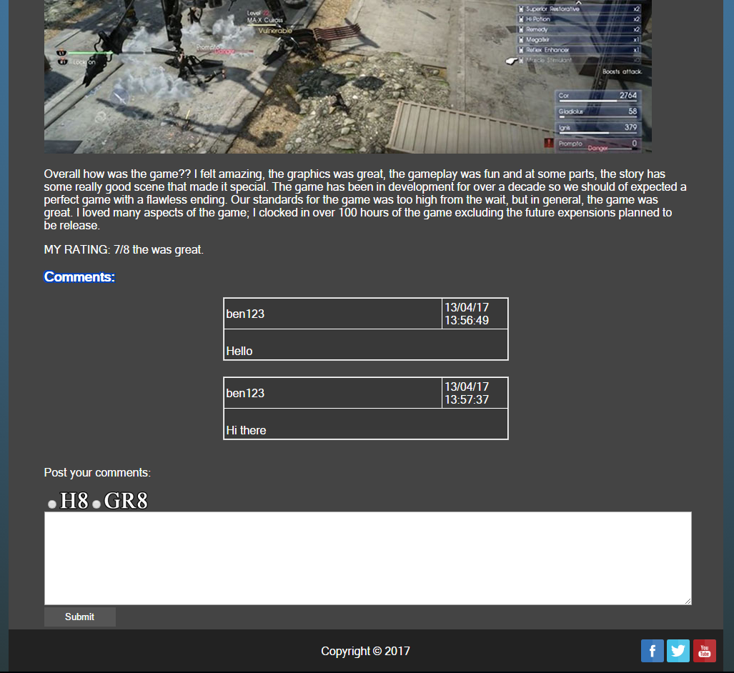

The user comment was successfully posted.

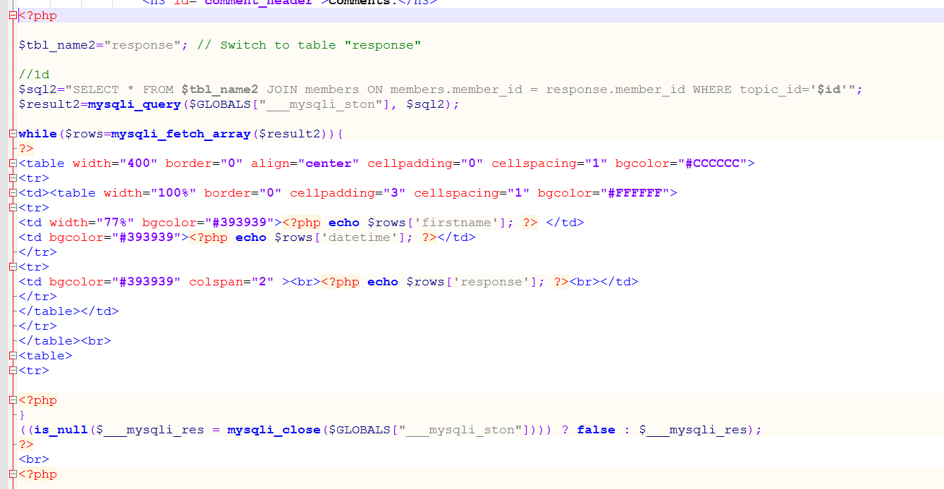

The review pages contain PHP that will retrieve comments from the responses table in the database and display them as a series of tables.

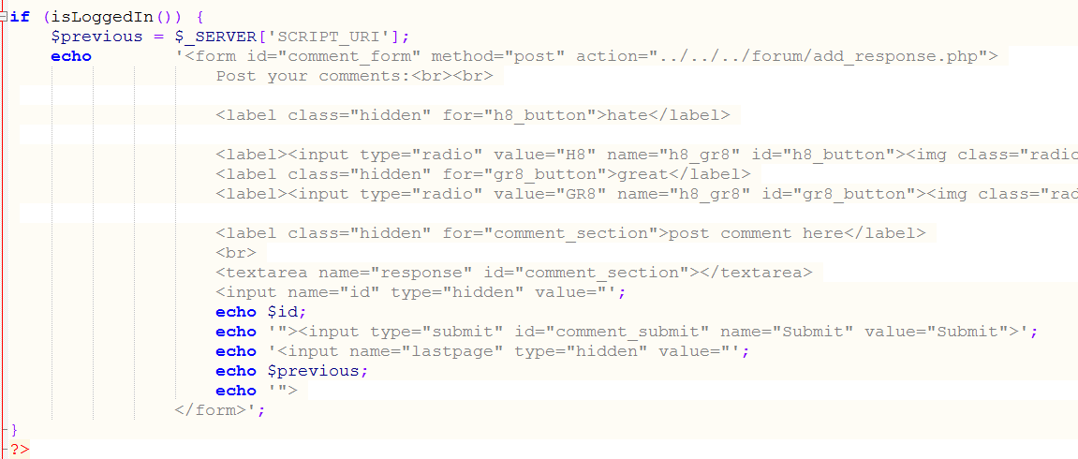

The form to submit comments will only appear when the user is logged in.

**Appendix**

**Team leader:**

Ben Zhang:          A00976551

**Team members:**

Andrew Main:     A00815430

Phat Le:               A01012144

Simon Shoban:    A00985653

Cameron Roberts:  A00966003

**Milestone 4 – Deployed Javascript-enabled Website**

**Game Review 8™ Game Review Web System**

**COMP 1536 Group 6**

**Date: 03-14-2017**

**Table of Contents**

**1. Form validations pg.13**

1.1 Validation requirements pg.13

1.2 Validation implementations pg.14

**2. Form Testing pg.16**

2.1 Field testing pg.16

        2.2 Form testing pg.17

2.3 Javascript disabled testing pg.17

**3. Jquery widget pg.18**

3.1 Reasons & Advantages pg.18

3.2 Javascript disabled testing pg.21

**4. Reflection pg.22**

4.1 Success with publish and test pg.22

4.2 Problems encountered pg.22

**Appendix pg.23**

**List of items completed:**

1. Input requirements definitions table
2. Implementation of validation requirements
3. Test form & Testing documentation table
4. Third party widget & reasoning
5. Test website with Javascript disabled
6. Published & tested website
7. Fixed image rendering issues from milestone 3

**URL to sign_up.html:**

[**http://students.bcitdev.com/A00985653/COMP-1536-Project/sign_up.html**](http://students.bcitdev.com/A00985653/COMP-1536-Project/sign_up.html)

**URL to about.html:**

[**http://students.bcitdev.com/A00985653/COMP-1536-Project/about.html**](http://students.bcitdev.com/A00985653/COMP-1536-Project/about.html)

**1.Form validation:**

**1.1 Validation requirements:**

sign_up.html page:

|  |  |  |
| --- | --- | --- |
| Form ID | Data Format/ Reg Exp | Explanation |
| username | /^[A-Za-z0-9_]{5,20}$/; | Any characters and numbers, no special letters. User name is between 5-20 character. |
| email | /^[A-Z0-9._%+-]+@[A-Z0-9.-]+\.[A-Z]{2,}$/i | An address with 1 or more A-Z0-9._%+- characters, followed by @ sign, and 1 or more A-Z0-9.- characters for the type of mail service, such as @hotmail or @gmail. Then it is followed by a . with 2 or more letters for the TLD, such as .ca or .com. The email is case insensitive. |
| password | /^(?=.*\d)(?=.*[a-z])(?=.*[A-Z])(?=.*[#?!@$*%^&-]).{5,20}$/; | Password must have at least 1 capital letter and be between 5-20 characters long. It must contain at least one of these special characters: : #?!@$*%^&-, as well as at least one number. |
| confirm_password | if (document.getElementById ('password').value != document.getElementById('confirm_password') | Must match password. |
| gender | if (!gender[0].checked && !gender[1].checked && !gender[2].checked) | A user must enter a gender, and only 3 values are allowed. |
| dateOfBirth | /[0-9][0-9][0-9][0-9]-[0-9][0-9]-[0-9][0-9]/ | Checks if user entered the date format yyyy-mm-dd. |
| terms_box | if(!document.getElementById  ('terms_agree').checked) | Terms and conditions must be checked. |

**1.2 Validation implementations:**

Validation is done with Javascript, an external script “form_validation.js” is linked to sign_up.html.

The form’s onsubmit is linked to a method called validate(form), which checks the entire form.

The fields with regular expression are validated by using the test() method, to match the regular expression with the form input fields.

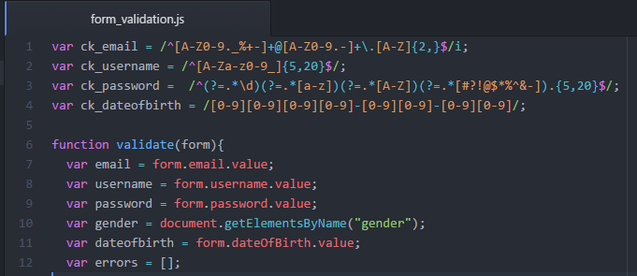

This is the regular expressios for the four fields above, they are then validated with an if statement, below is a validation for email:

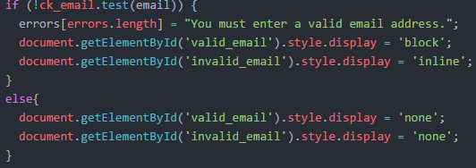

The ids starting with “valid_” are the warning messages below each fields, they are hidden by defualt and are displayed in block when there is an error, and are then hidden again when user fixes their input.

The ids starting with “invalid_” are the red *s to indicate the fields that require fixing.

The fields that do not require regular expression uses logic comparison or methods to validate instead, below is a validation for terms of service:

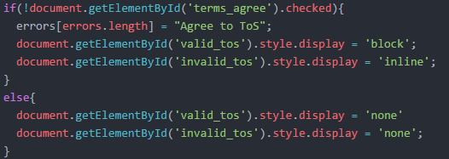

The fields that do not validate successfully are logged into an errors[] array, and after all validations are processed, the validate(form) method returns false if the errors[] array is not empty, and true otherwise.

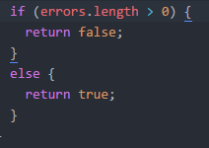

This is the website when no inputs are submitted:

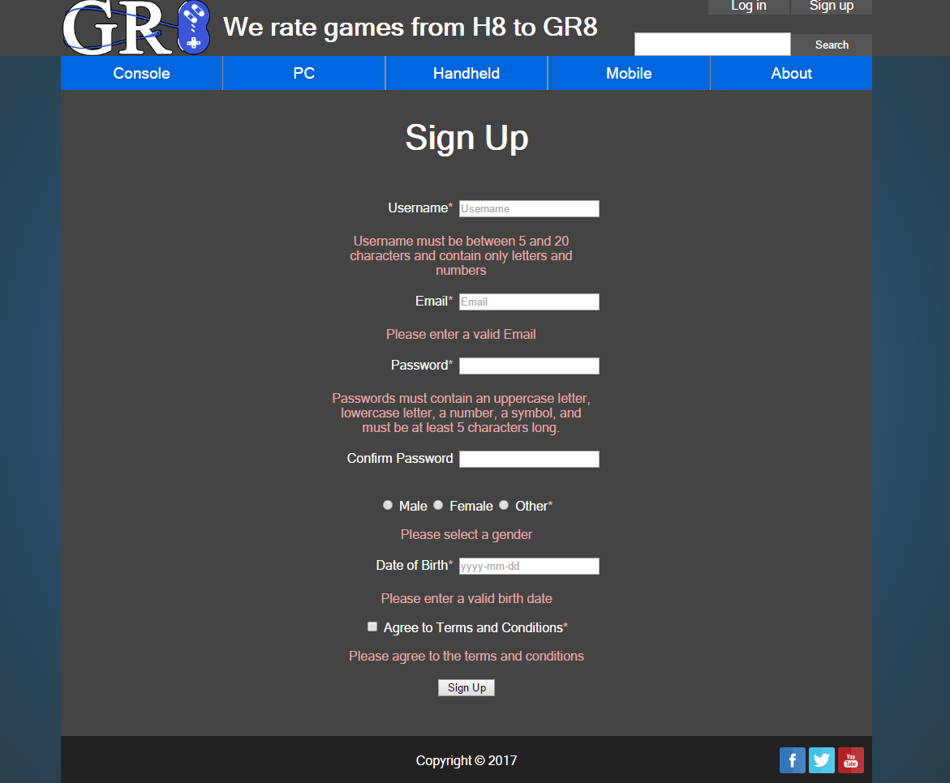

**2. Testing**

**2.1 Field testing**

Tested by Akemi and her group memers, Ian Lo, Simon Wu, and Jacky Li.

sign_up.html page:

|  |  |  |
| --- | --- | --- |
| **Field level testing** | | |
| **Field ID** | **Problems** | **Improvements made** |
| username | Did not limit max number of characters. | Limited to 20 characters. |
| email | Did not work with lower case letters. | Added lowercase testing. |
| password | Was too simple, did not include checks for capital letters, special characters, etc. | Changed to check for capital, have at least 1 special characters, and be at least 6 characters long, 20 characters max. |
| dateOfBirth | Old pattern was mm-dd-yyyy, this isn’t common standard. | Changed to yyyy-mm-dd. |
| terms_box | Did not require users to check. | Implemented terms box check. |

**2.2 Form testing**

sign_up.html page:

|  |  |  |
| --- | --- | --- |
| **Form level testing** | | |
| **Form flow** | **Problem** | **Improvements made** |
| Displaying errors | Was using alert() to provide feedback to users, it is unprofessional and annoying to users, so based on feedback, improvements were made. | Used hidden text below each field to display error messages by setting each field to be visible on submit. |
| Colors for errors | Color was bright red, color did not contrast well with the grey background. | Now uses a tinted red instead to improve visuals. |

**2.3 Javascript disabled testing**

The sign_up.html and the form are tested with Javascript disabled by setting the Browser to block all Javascripts.

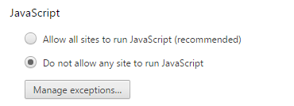

The form submission still functions properly with Javascript disabled.

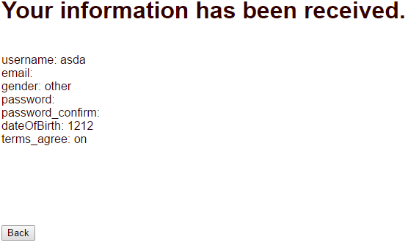

Note that email still provides warning if an input is entered, due to the input type of email causing the browser to validate without Javascript present.

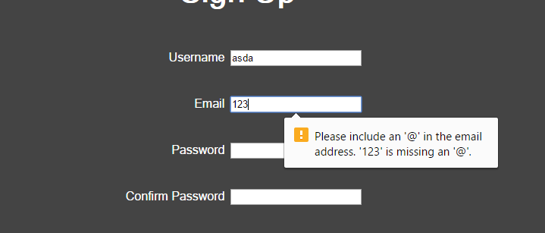

**3. Jquery widget**

**3.1 Reason & Advantages**

We used the Accordion jQuery plugin for our website for this project, the link is down below:

<https://jqueryui.com/accordion/>

This plugin allows us to display tabs of information, by clicking on the the dropdown menu, and clicking it again will hide the content.

We chose this plugin to provide a more modern look to our website, and add interactivity to it as well. The user can dynamically choose which tabs of information they want to view, and hide anything they do not want to see.

This plugin was implemented in the About page:

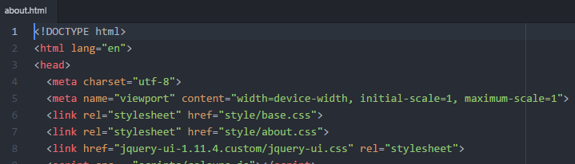

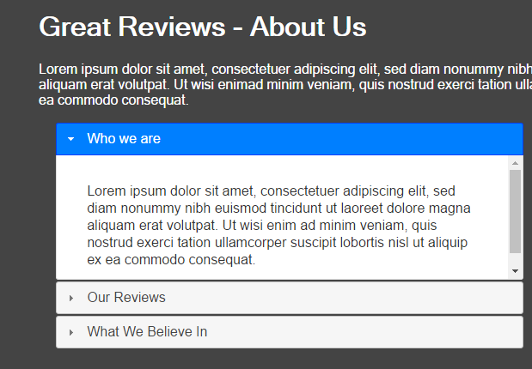

Additionally, we implemented an iframe widget to display a map of our offices in the About page, we chose this plugin because it provides a conveinent and quick view to the map without the the need for users to find it on google map, and makes the experience smoother and more professional.





Finally, we had fun and implemented a Javascript for changing the website color based on the time of the day, this is during the night time:

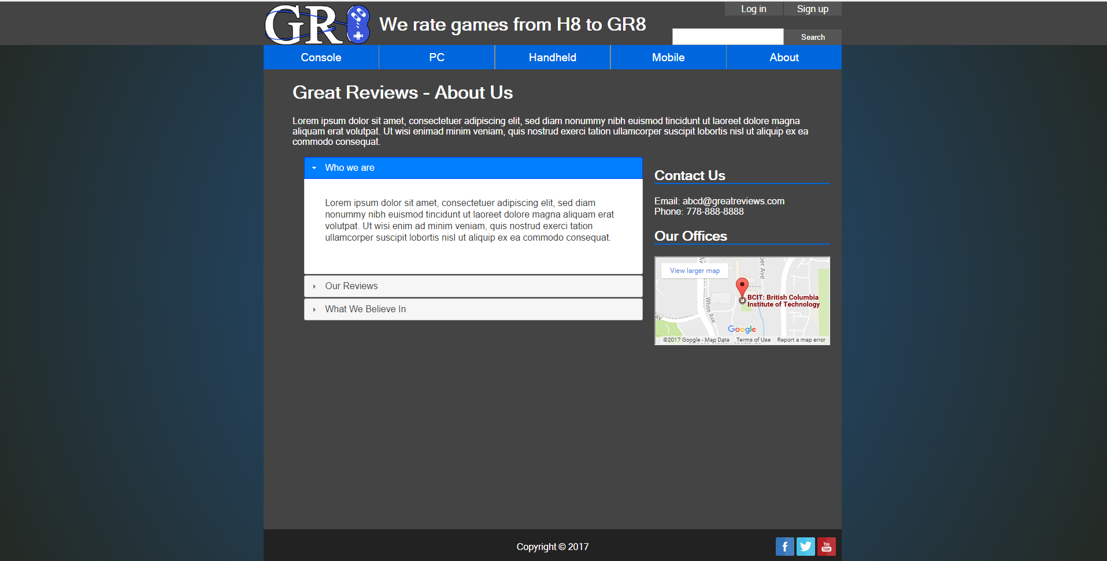

And this is the color during the daytime, notice how it changes every hour.

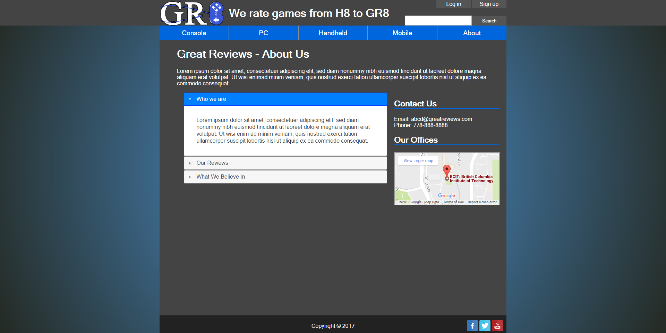

Implementation of color change Javascript:

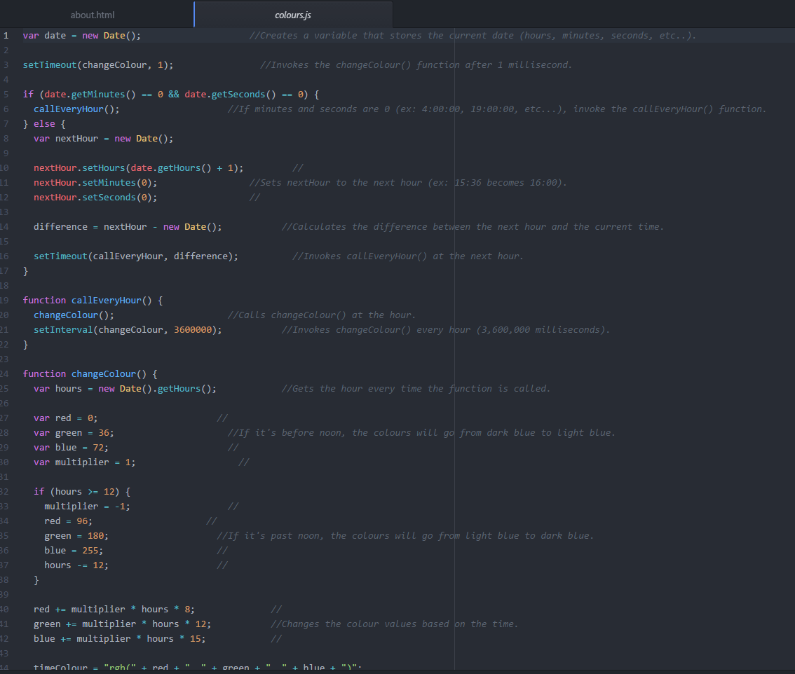

**3.2 Testing with Javascript disabled**

We tested our website again with the inclusion of widgets, the form page still functions properly, while the about page with the widgets are also displaying the proper information when their widgets are no longer running.

Here is a view at our about page with Javascript turned off:

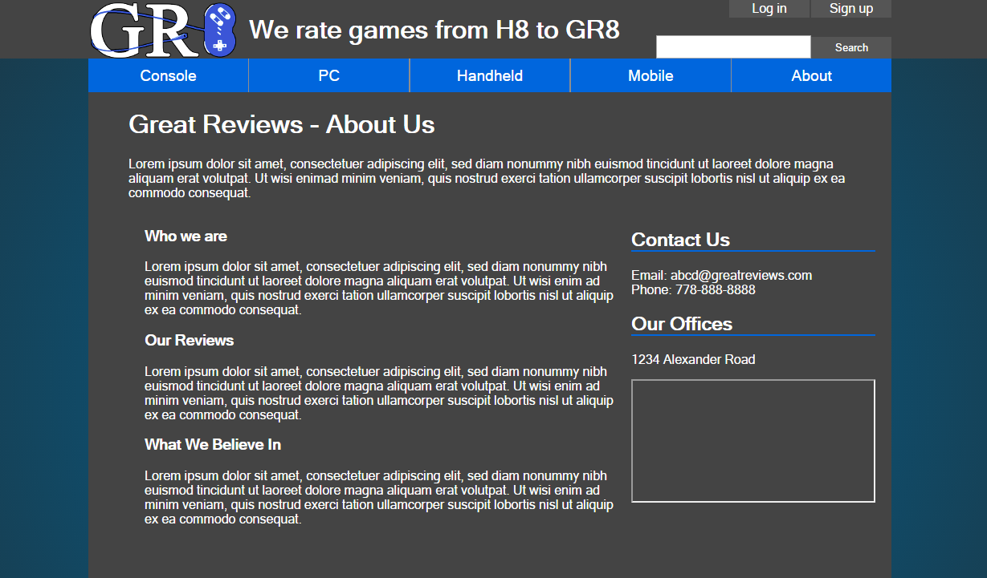

**4. Reflection**

**4.1 Success with publish and test**

The website functions properly after being published on our bcit student server, the form validations and the widget behave appropriately, and the form submission functions properly with Javascript disabled.

**4.2 Problems encountered**

No issues were encountered when publishing our website. However, we struggled to find a proper regular expression for the email field, as well as a strong and secure regular expression for the password field. We did eventually worked it out as a group.

Additionally, finding an appropriate widget to fit into our website was hard at first, because there are many options and some were either too complicated or did not fit with our website. Again, we eventually found the suitable widget and are happy with our decisions.

Overall, this milestone was challenging, but not difficult. I am proud of the hard work our group members have put in and hope we can keep it up for the next milestone.

**Appendix**

**Team leader:**

Ben Zhang:          A00976551

**Team members:**

Andrew Main:     A00815430

Phat Le:               A01012144

Simon Shoban:    A00985653

Cameron Roberts:  A00966003

**Milestone 3 – Skeleton website**

**Game Review 8™ Game Review Web System**

**COMP 1536 Group 6**

**Date: 02-15-2017**

**Table of Contents**

**1. Overview pg.25**

1.1 Link pg.25

1.2 List of items completed pg.26

        1.3 Additional work pg.26

**2. Documentation of work pg.27**

2.1 Screenshots of front page pg.27

        2.2 Screenshots of table pg.27

2.3 Screenshots of form pg.28

2.4 Screenshots of base.css pg.28

**3. Key issues pg.29**

3.1 Encountered problems pg.29

3.2 Outstanding problems pg.29

**4. Testing pg.29**

4.1 A/B testing pg.29

4.2 Accessibility testing pg.29

4.2.1 Browser compatibility pg.30

4.2.2 Device compatibility pg.32

4.3 HTML/CSS validation pg.32

**Appendix pg.33**

**1.Overview**

This document showcases the skeleton websites of our game review system. It provides the quick links, documentation of work, list of key issues we encountered, and documentation for A/B testing.

**1.1 Link**

Index page:

http://students.bcitdev.com/A00976551/Project%20Demo/index.html

Devices page – Console :

http://students.bcitdev.com/A00976551/Project%20Demo/devices/console.html

Devices page – Handheld:

http://students.bcitdev.com/A00976551/Project%20Demo/devices/handheld.html

Devices page – Mobile:

http://students.bcitdev.com/A00976551/Project%20Demo/devices/mobile.html

Devices page – PlayStation 4:

http://students.bcitdev.com/A00976551/Project%20Demo/devices/console/ps4.html

Devices page – Xbox One:

http://students.bcitdev.com/A00976551/Project%20Demo/devices/console/xbone.html

Devices page – Nintendo Switch:

http://students.bcitdev.com/A00976551/Project%20Demo/devices/console/switch.html

Consoles page – PC:

http://students.bcitdev.com/A00976551/Project%20Demo/devices/pc.html

Consoles page – PlayStation Vita:

http://students.bcitdev.com/A00976551/Project%20Demo/devices/handheld/vita.html

Consoles page – Nintendo 3DS:

http://students.bcitdev.com/A00976551/Project%20Demo/devices/handheld/3ds.html

Consoles page – iOS:

http://students.bcitdev.com/A00976551/Project%20Demo/devices/mobile/ios.html

Consoles page – Android:

http://students.bcitdev.com/A00976551/Project%20Demo/devices/mobile/android.html

About page:

http://students.bcitdev.com/A00976551/Project%20Demo/about.html

Sign up page:

http://students.bcitdev.com/A00976551/Project%20Demo/sign_up.html

**1.2 List of items completed**

* Standard HTML template for all pages
* Base CSS template for all pages
* Skeleton pages for the entire website
* Skeleton page for Sign up and Review pages that contains a form
* Skeleton pages for Consoles that contain tables
* Implemented responsive design for all pages
* Tested pages on Internet Explorer, Mozilla Firefox, Microsoft Edge, and Google Chrome.
* A/B Testing

**1.3 Additional work**

* Fixed milestone 2 issue – Added user comments in review page again
* Added tables of system specifications to device pages

**2.Documentation of work**

**2.1 Screenshots of front page**

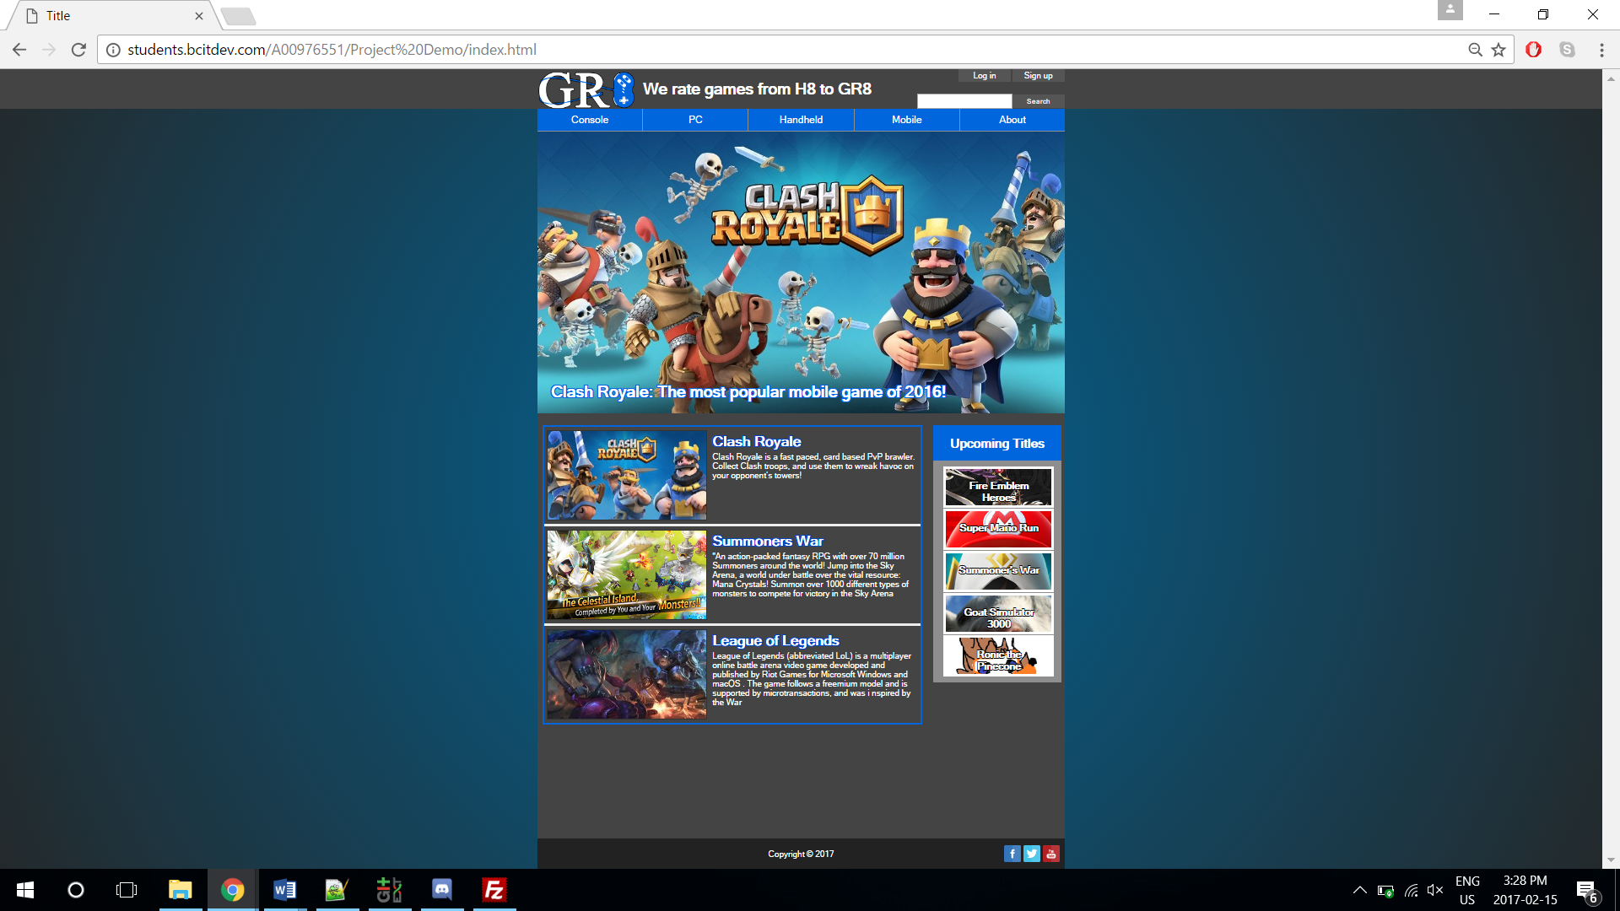

**2.2 Screenshots of tab**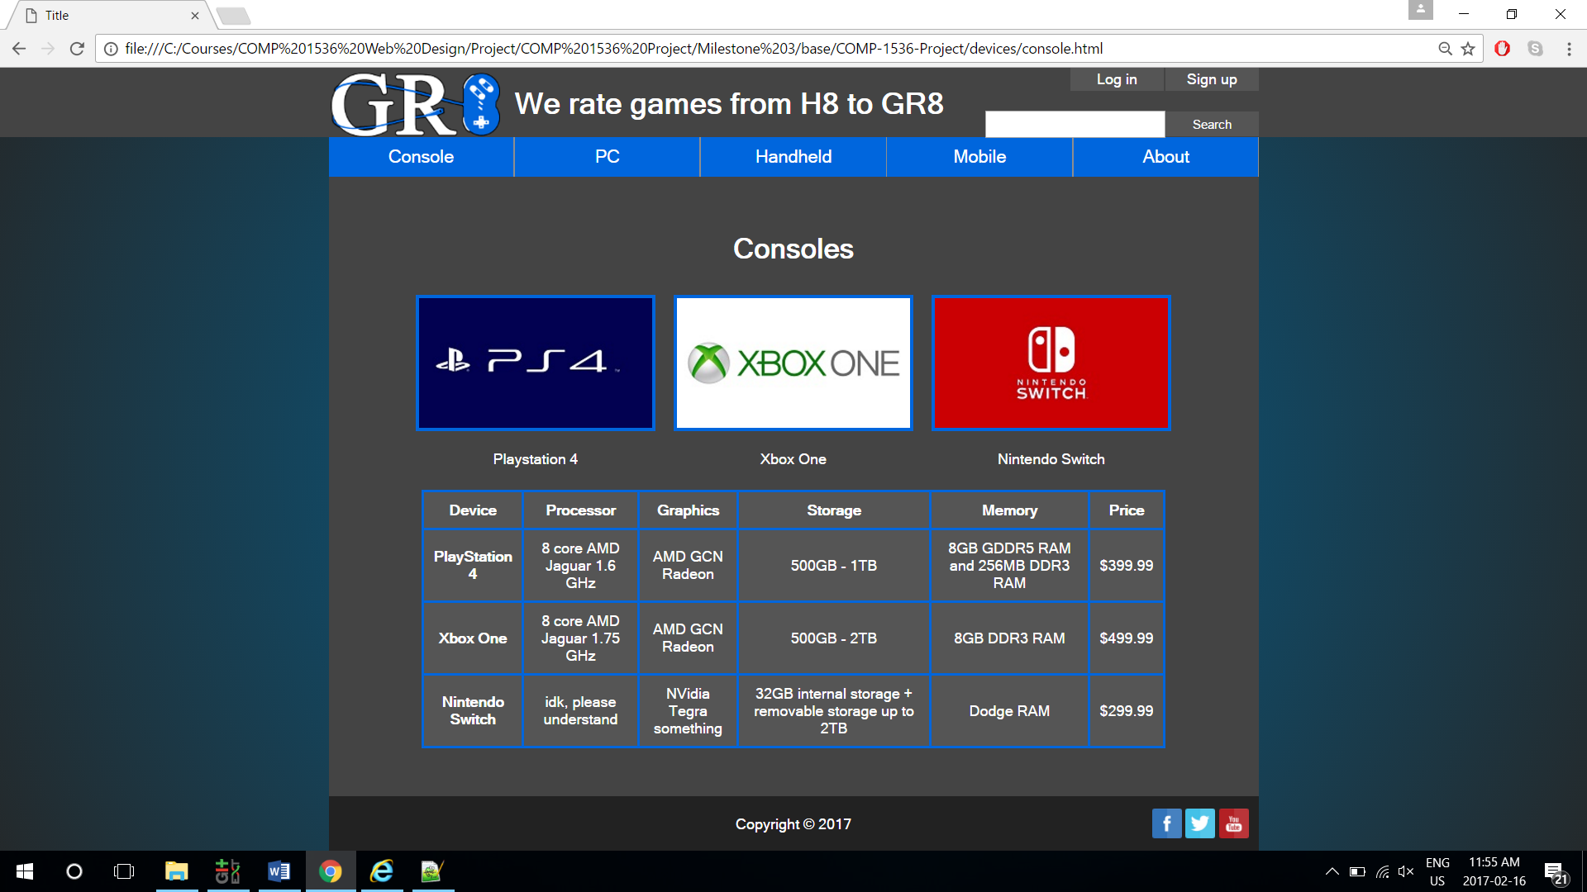

**2.3 Screenshots of form**

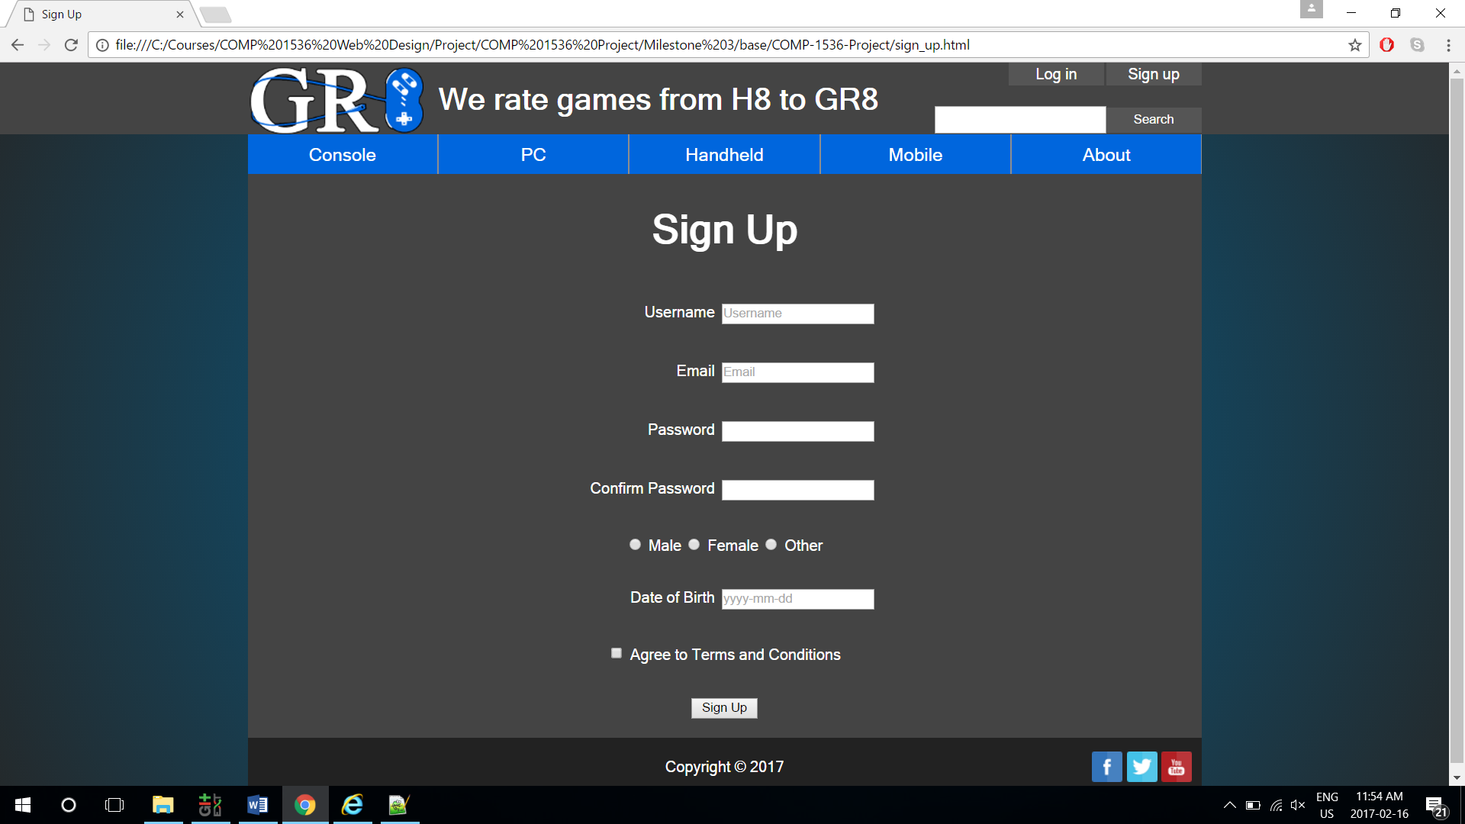

**2.4 Screenshot of base.css**

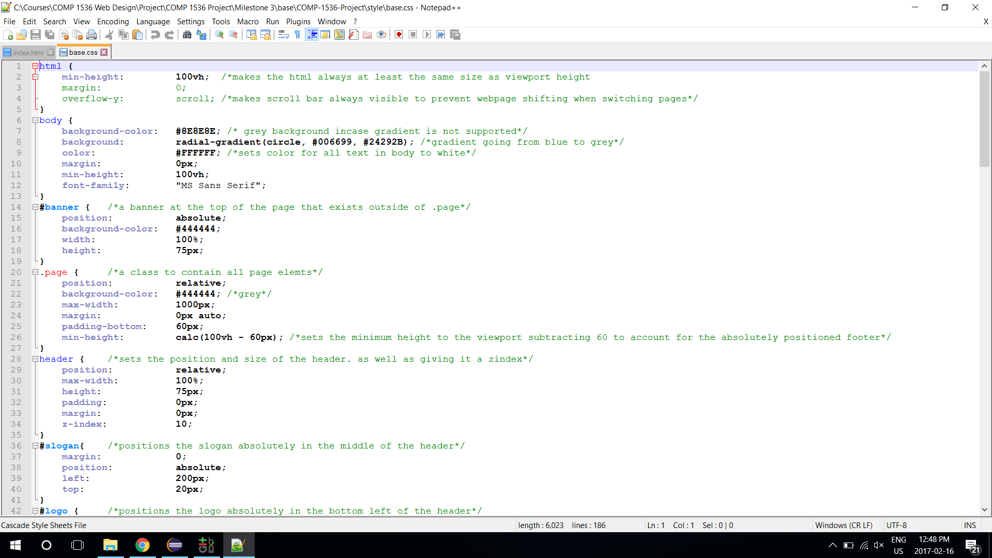

**3.Key issues**

**3.1 Encountered problems**

During the development of our webpages, we found that the initial design scales poorly on different screen resolutions. Therefore, we adjusted the website structure from being static to window rescaling to responsive. Also, we used media query and viewport to adjust the elements of the website to fit on a mobile device.

**3.2 Outstanding problems**

Our current issues mainly revolve around dynamic web elements, such as having a log in bar pop up when clicking the log in page, and having only the navigation bar stay static at the top when scrolling down. These issues can be resolved when we apply JavaScript to our website.

**4.Testing**

**4.1 A/B testing**

We conducted A/B testing on our discord group, which consists of other project group members. We thought having subjects with experience with web design would provide us with more critical feedbacks.

The test was conducted with Strawpoll over discord. The subjects were given two different links to two websites with different layouts, and were asked to vote for the layout that they felt was better after they were given ample time to navigate through each, they were also required to give reasons for their vote.

The results were convincing, with a 83% (10 out of 12) vote for design 1. Most subjects thought the contrast between the border and background gradient is more pleasant to view, and the blue subject titles help highlight each individual article.

**4.2 Accessibility testing**

We conducted numerous accessibility testing throughout the skeleton page development. We ensured that the pages were compatible with four major browsers: Internet Explorer, Mozilla Firefox, Microsoft Edge, and Google Chrome. Also, we employed responsive design to let our pages adjust dynamically per the display, which results in a great mobile layout without needing to create separate CSS style sheets for it.

**4.2.1 Browser compatibility**

We tested our pages on four primary browsers, the Internet Explorer, Mozilla Firefox, Microsoft Edge, and Google Chrome. The pages could run properly on all four browsers, and the pages look consistent throughout each browser.

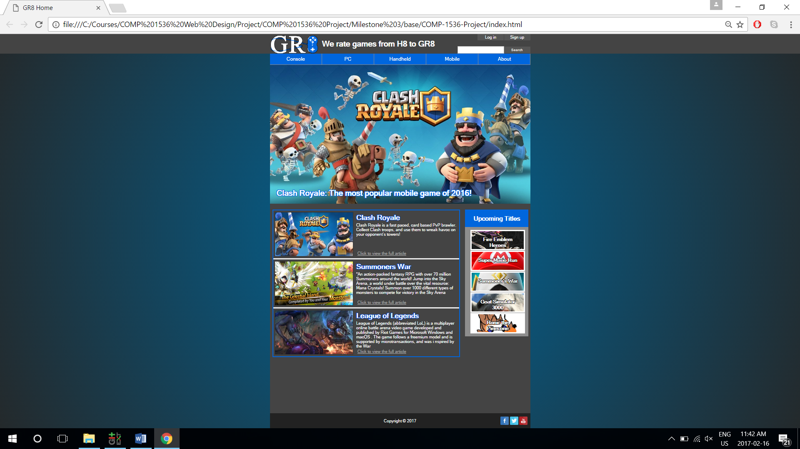

Page displayed on Chrome

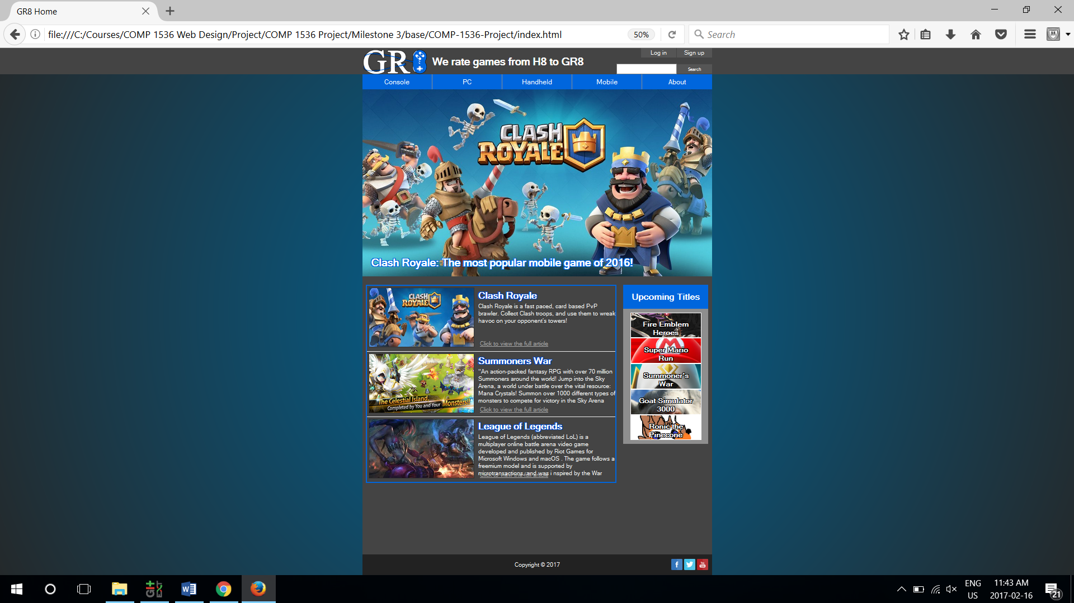

Display on Firefox

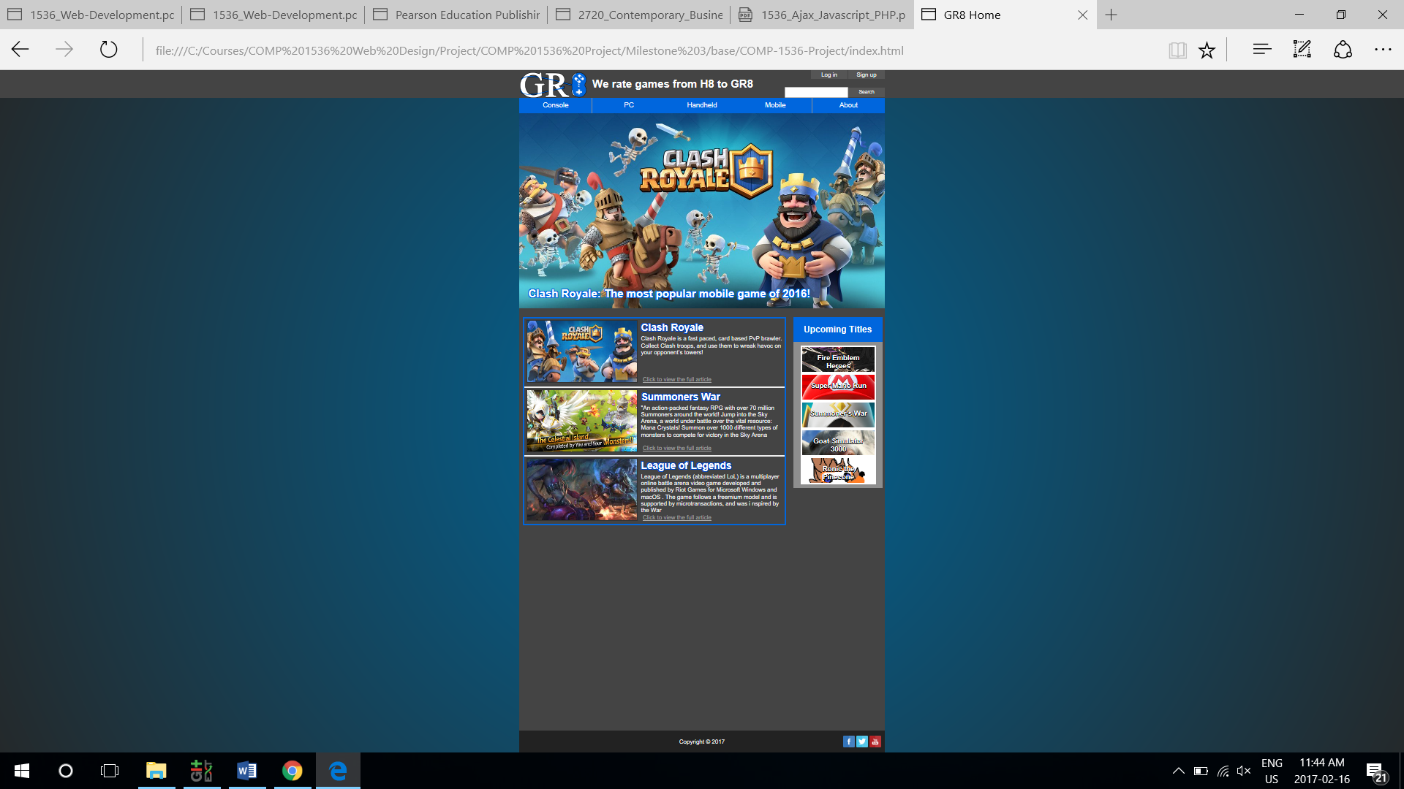

Display on Edge

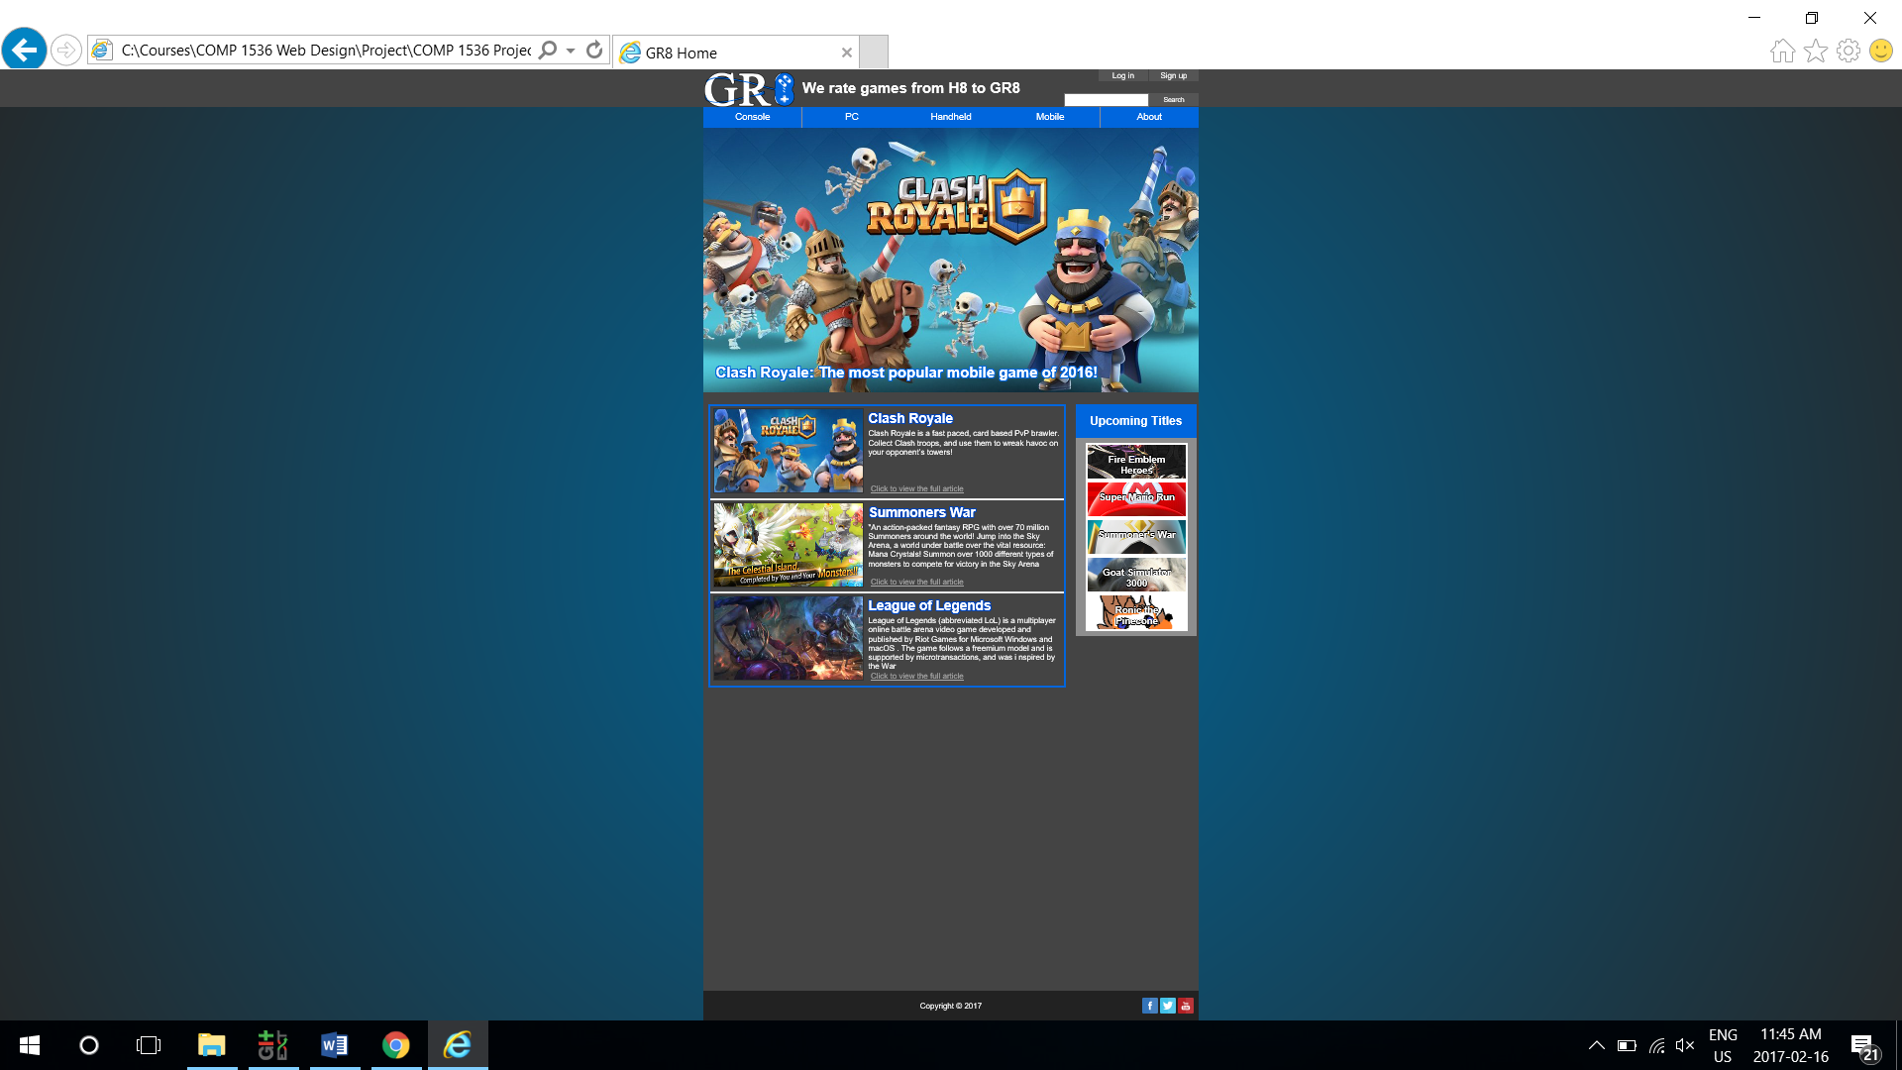

Display on Internet Explorer

**4.2.2 Device compatibility**

The pages were also tested on mobile devices. We used Chrome’s inspector to test for responsiveness, and used iPhone 6s and Android phones to test out the actual webpages. Some elements such as the slogan and log in/sign up buttons will scale per page size, and behave differently in different sizes. This allows us to display our website nicely in various screen resolutions.

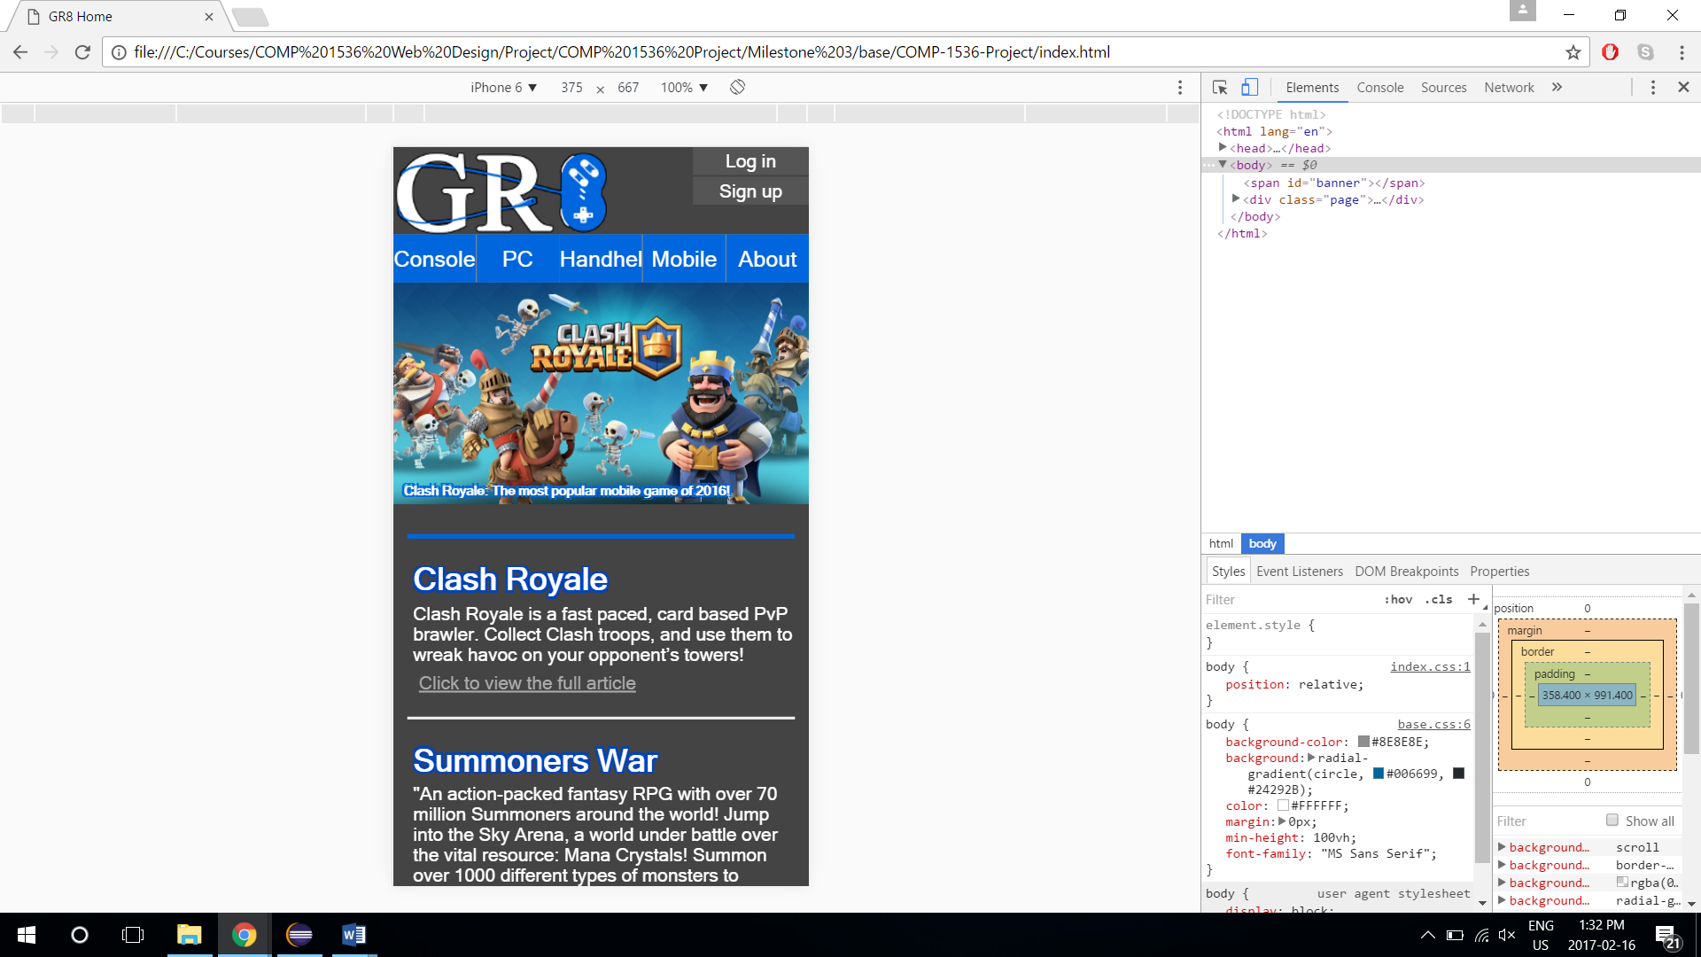

Page on mobile display

**4.3 HTML/CSS validation**

All pages pass the HTML 5 and CSS validation.

**Appendix**

**Team leader:**

Ben Zhang:          A00976551

**Team members:**

Andrew Main:     A00815430

Phat Le:               A01012144

Simon Shoban:    A00985653

Cameron Roberts:  A00966003

**Milestone 2 - Website Hierarchy and layout**

**Game Review 8™ Game Review Web System**

**COMP 1536 Group 6**

**Date: 01-28-2017**

**Table of Contents**

**1.Project site map pg.35**

1.1 Overview pg.35

1.2 Site hierarchy map pg.35

        1.3 Design reasoning

**2.Page layout pg.36**

2.1 Wireframes pg.36

2.1.1 Home page pg.36

2.1.2 Console type page pg.38

2.1.3 Device page pg.39

2.1.4 Review page pg.40

2.1.5 About page pg.41

2.1.6 Sign up page pg.42

        2.2 Proposed color scheme pg.43

2.2.1 Color scheme design pg.44

2.3 Print layout pg.45

        2.4 Page design reasoning pg.46

**3. Revised changes pg.46**

**Appendix pg.47**

**1.Project Site Map**

The project site map describes the hierarchical relationships between web pages, and provides a clear view on navigational structure.

**1.1 Overview**

Game Reviews 8™ Web system uses a 4-layer structural design consisting of: the main page, console type page, device page, and reviews page. The home page is the main page where users have access to the most popular articles, a list of upcoming games, the signup page, as well as navigate to a console type page for specific reviews. Upon entering the console type page, users can click further into the device they want, and bringing them to a list of reviews for that device.

If a user knows exactly which device they want to read reviews for, they can also select the device from a drop-down menu when hovering over the console type navigational bars for fast travel. In addition, users can login or sign up for an account by clicking the login/sign up button to the top right of the main page, as well as read about the website at the About page.

**1.2 Site Hierarchy Map**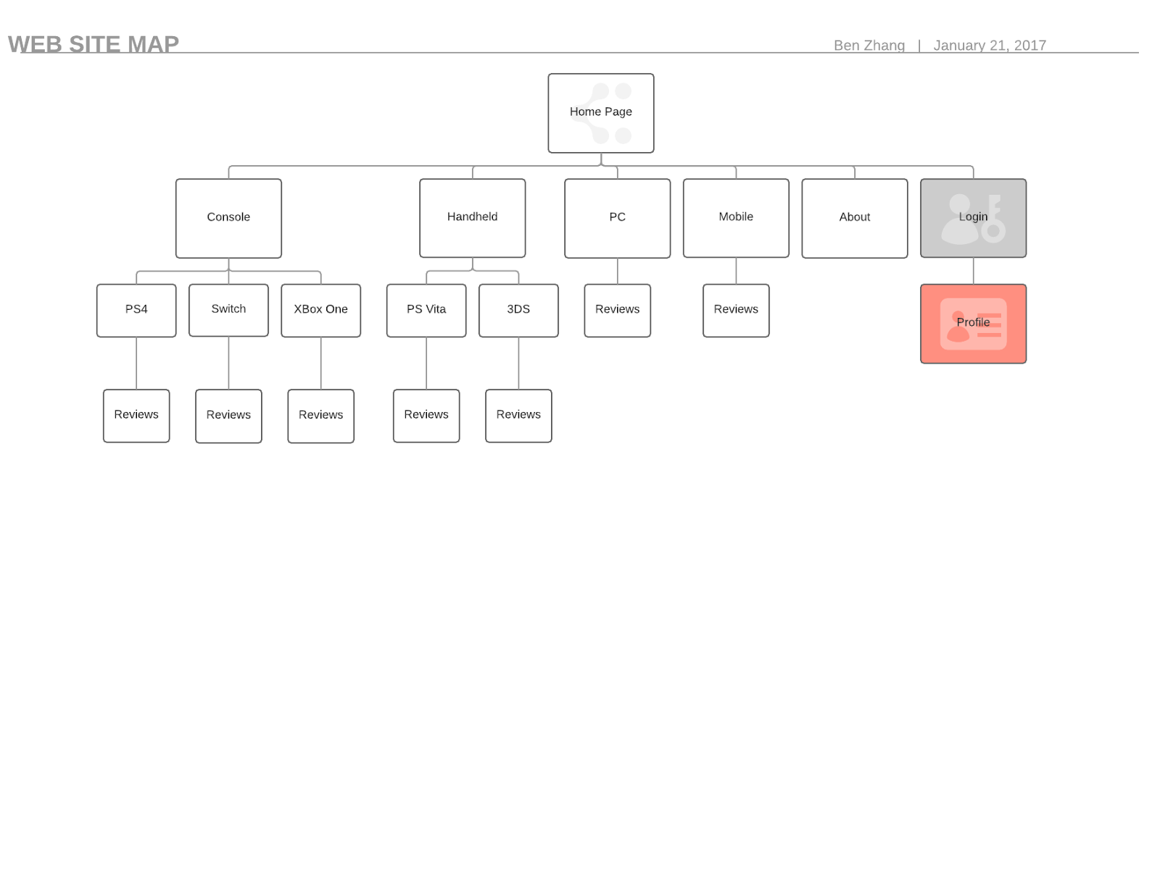

The site hierarchy map above describes how users can navigate through the web system and gain access to their desired reviews. Note that all websites will have access to the navigational bar, thus being able to return to the main page or go to any console type/device pages, but for simplicity their relationships are not shown here.

**1.3 Design Decisions**

The system employs categorization by console types, because console types are clear and distinct, where as categorization by genre will have too many genres and becomes difficult to manage, and other major game review websites such as IGN and Gamespot also categorizes their reviews based on console types.

The system allows user to either navigate layer by layer through the navigational bar, or directly through the drop-down menus. This ensures newcomers will not be overwhelmed by the website structure, and are guided by the clear navigation bar; while experienced users will be able to utilize the drop-down menu for a quicker access.

If a user logs into their account at any page, they are then returned to their previous page where they left off, this will create a smoother user experience.

**2.Page Layout**

Great Reviews 8™ websites will all contain the same header bar, with the website logo to the left, and the login, sign up, and search bars to the right. The navigation bar is then displayed below the header bar; main contents for the page is displayed below navigation bar, and the layout for main content differs for each page, followed by a common footer, which contains the copyright claim and social media links.

**2.1 Wireframes**

**2.1.1 Home Page**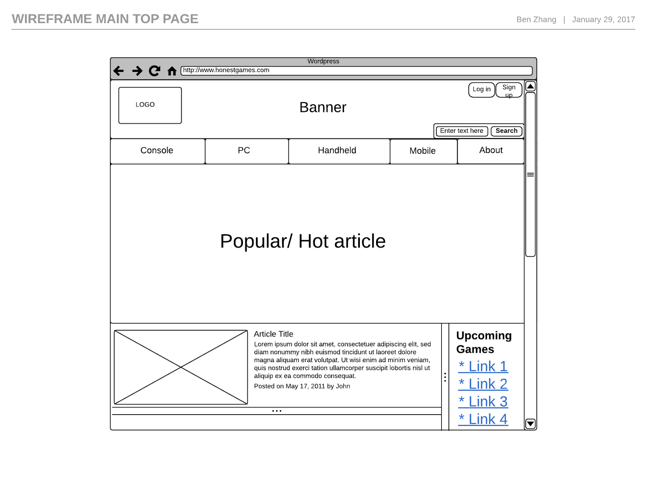

The main page consists of a large banner for the most popular article, followed by a column of newest reviews, beside a list of upcoming games.

The bottom of the main page contains the footer with the legal declarations of the website, and the social media links to the right.  
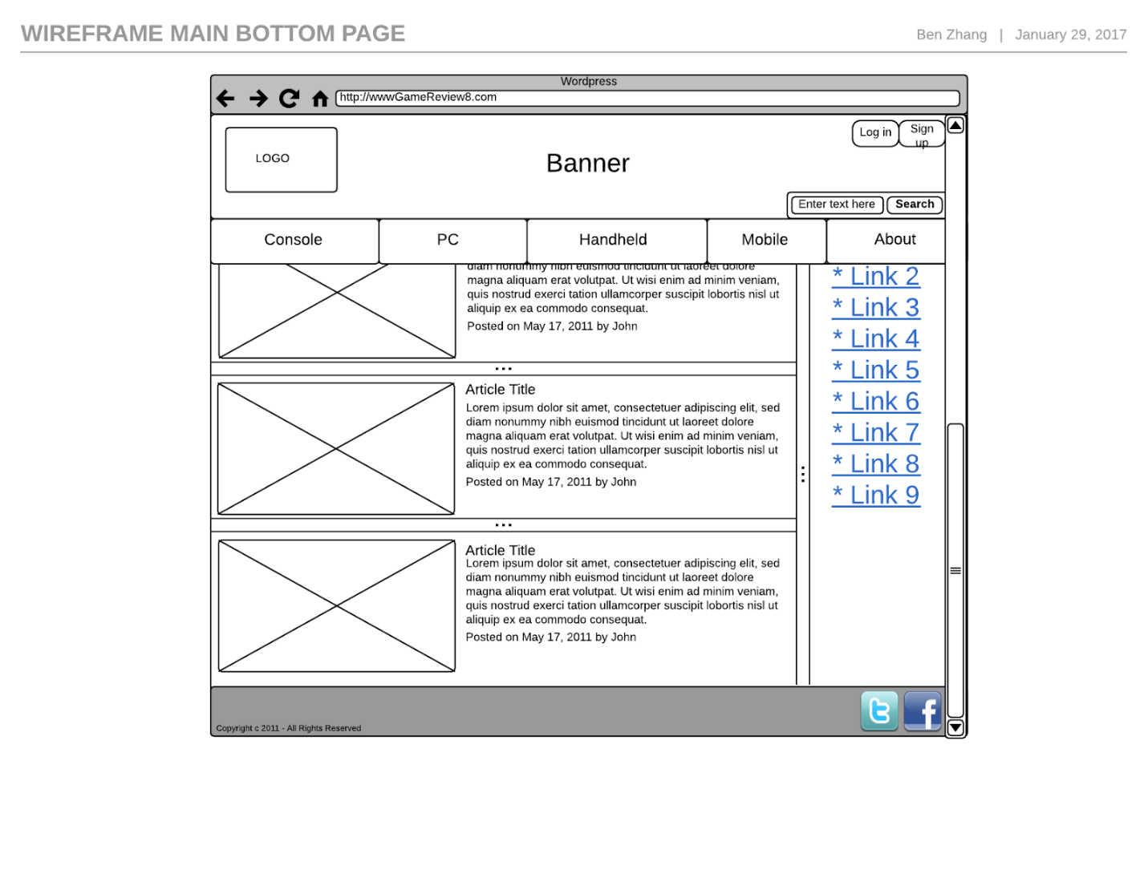

**2.1.2 Console Type page**

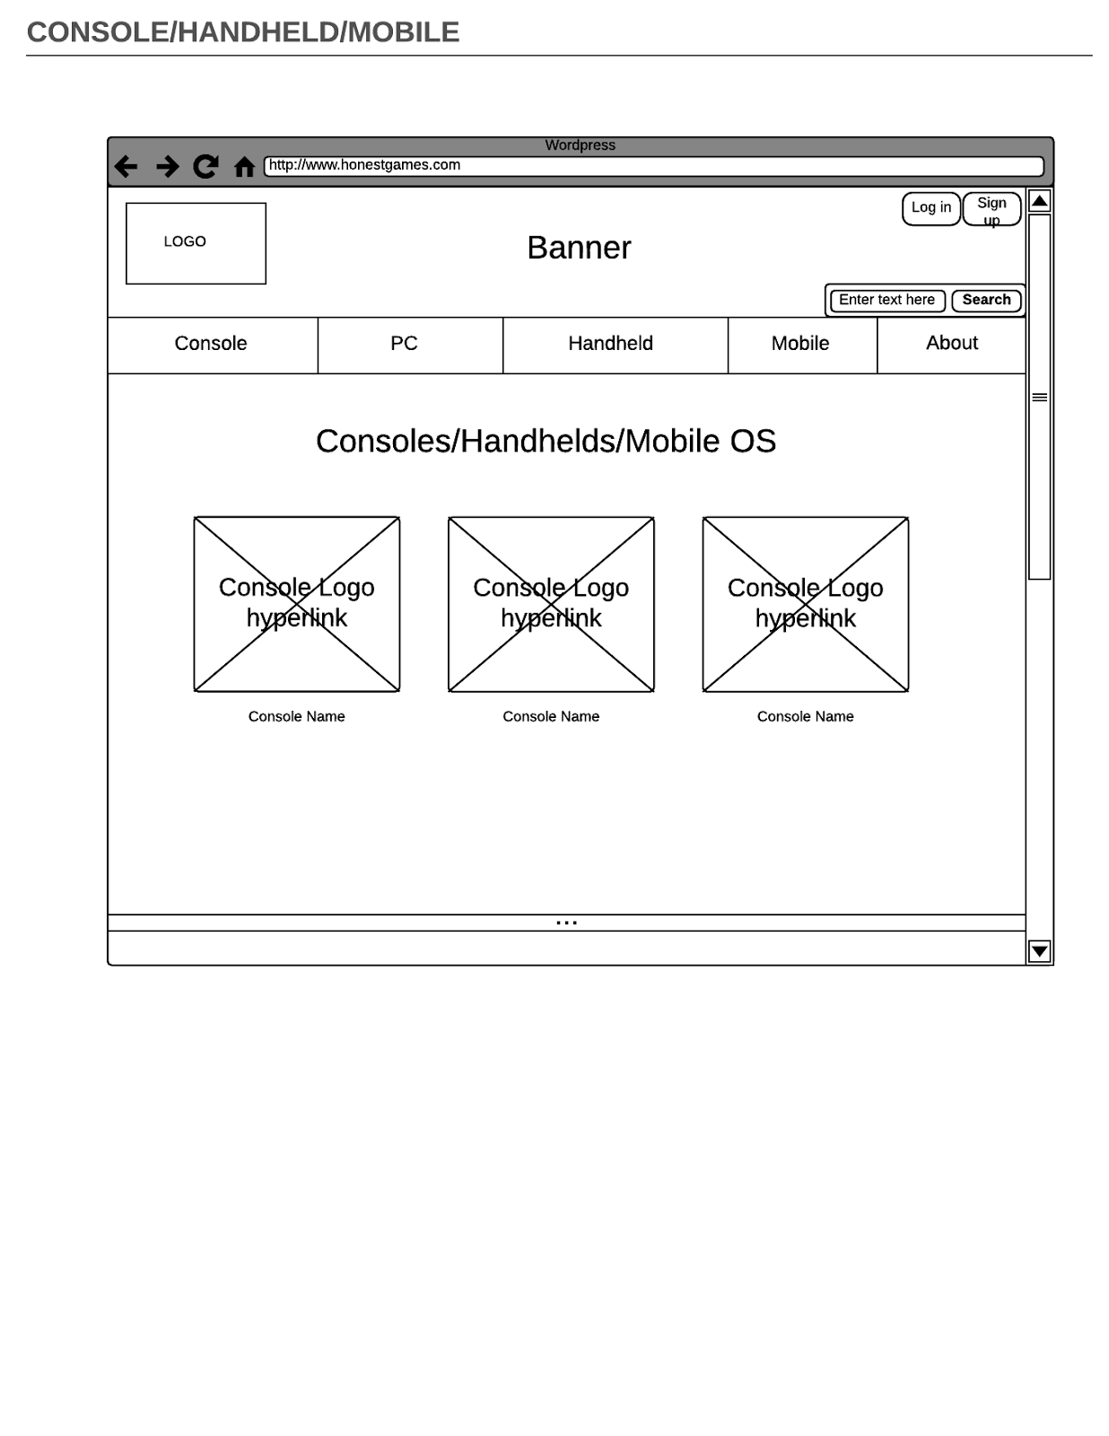

The Console type page mainly consists of the different devices in that console type, each device type is illustrated by large images. Also, the console system’s specifications will be listed in a table down below.

**2.1.3 Device page**

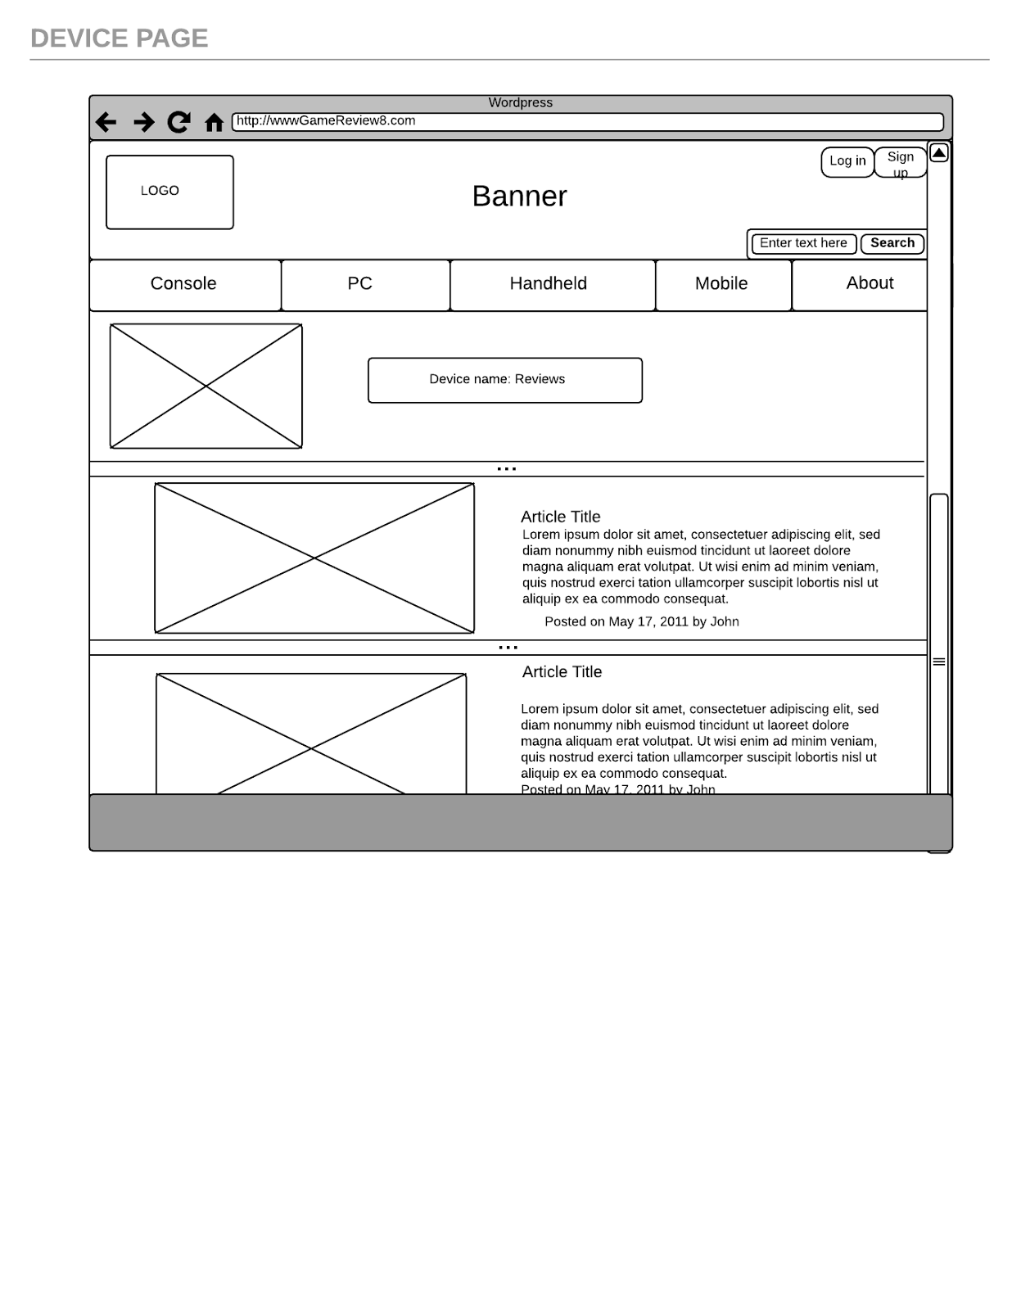

The device page consists of the device type and the newest review up top,, followed by the lists of reviews for that device. Each review is accompanied by an image to complement the visuals, followed by the article title, a short description of the review, and the time of the post.

**2.1.4 Review page**

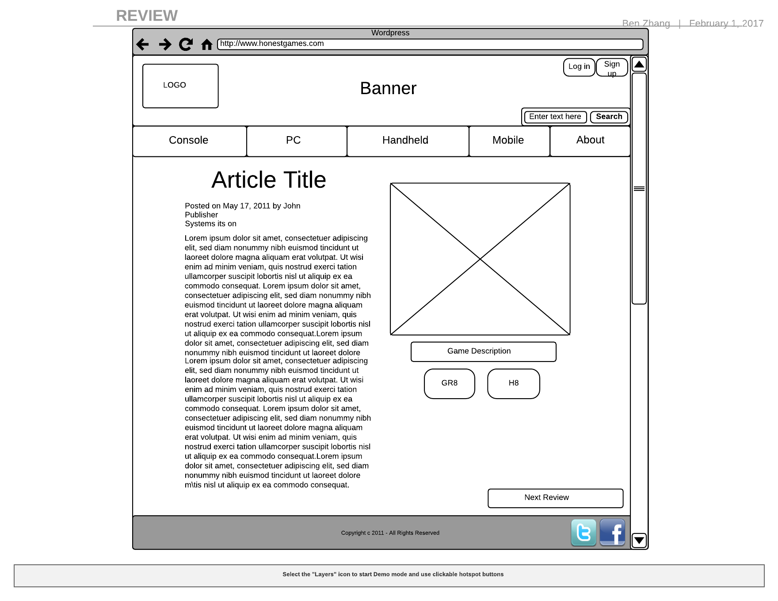

The Review page contains the review article title, followed by the related information of the article, such as the published date, publisher, and the device it is on. To the right side is the game image, and the game title description. Below them is the upvote and downvote button, but called GR8(great) or H8(hate) in this case. At the bottom of the page users can reply to the article with a form. To the bottom right of the page users can go to the next article in terms of published date.

**2.1.5 About page**

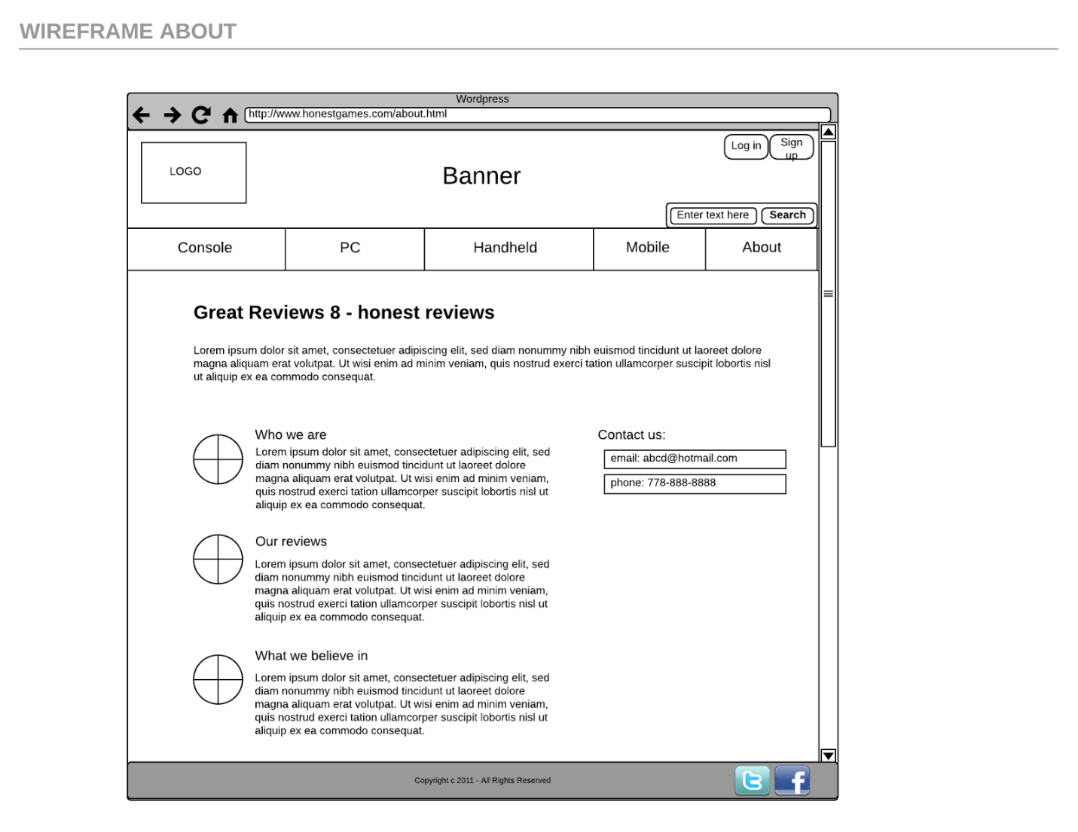

The About page contains a description of what Great Reviews 8™ is about, followed by some definitions of the goals and beliefs of the website. To the right side is our contact information.

**2.1.6 Sign up page**

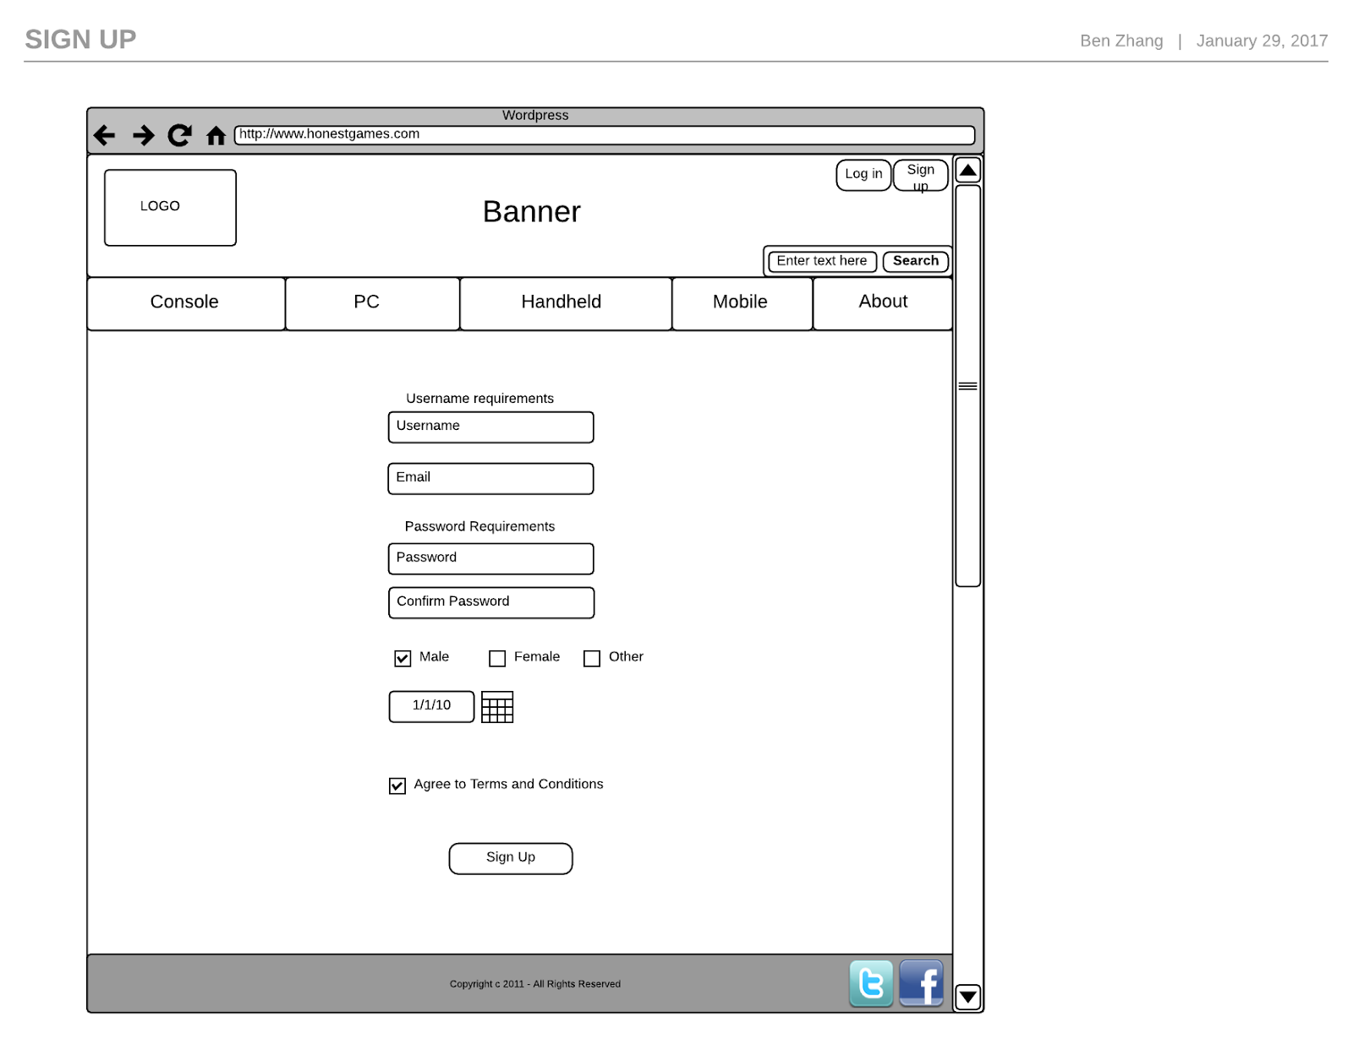

The Sign-up page consists of the fields of information users need to provide to register for an account, the fields include: username, e-mail, password, gender, and date of birth.

The users also need to click on Agree to Terms and Conditions to be able to create the account successfully.

**2.2 Proposed color scheme**

The main page background will be dark grey (#444444) as it will allow the content of the page to stand out. with the navigation buttons be a slightly lighter grey color (#555555) to create an illusion of depth to it; the margins separating the navigation bar will be filled with a blue gradiant. The text within the grey bars will be white, (#ffffff) giving it a contrast of 7.45:1. We plan to add some blue (#0066dd) to the boxes and the text within will be white text; the contrast between the two is 5.32:1. Even though we are only using black, white, blue and shades of grey, the simplistic color scheme will make the page content to stand out more as they have more color to them.

We tried to stay within the W3C recommended color guidelines, and stayed within the recommended AAA standards for majority of the content, aside from some small texts. We decided to not follow AAA standards completely, as it hinders design space greatly; therefore, limiting our choices of color significantly. Below are the contrast ratios for the website colors:

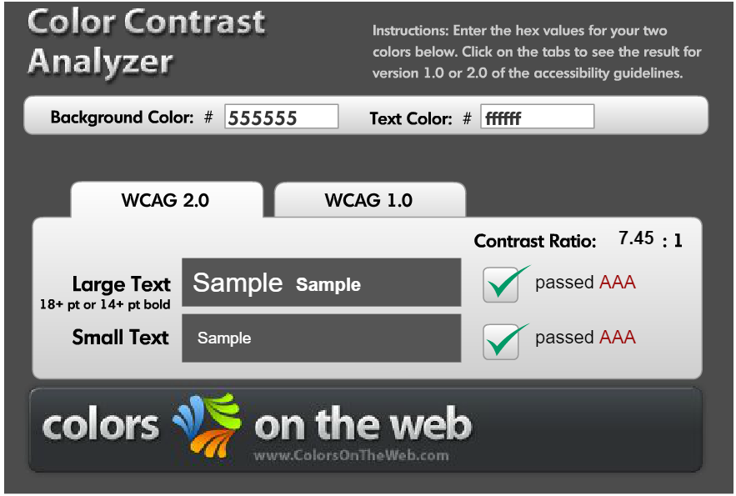

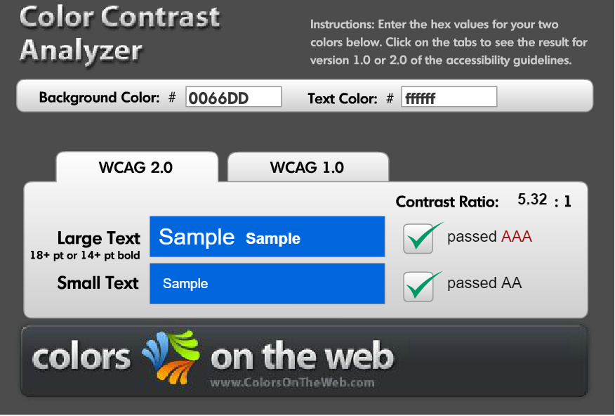

**2.2.1 Color scheme design**

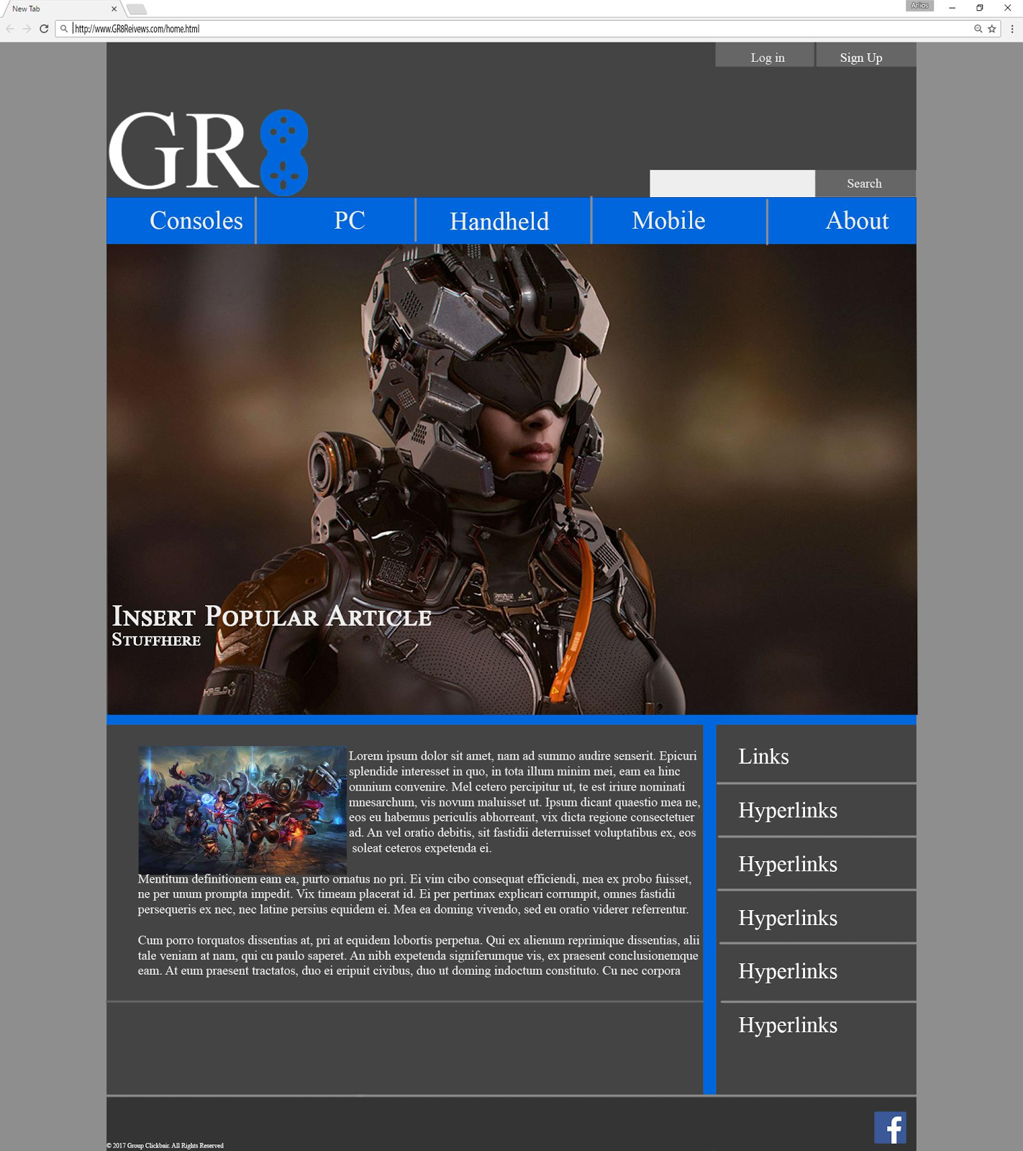

Above is the prototype website layout design,

**2.3 Print layout**

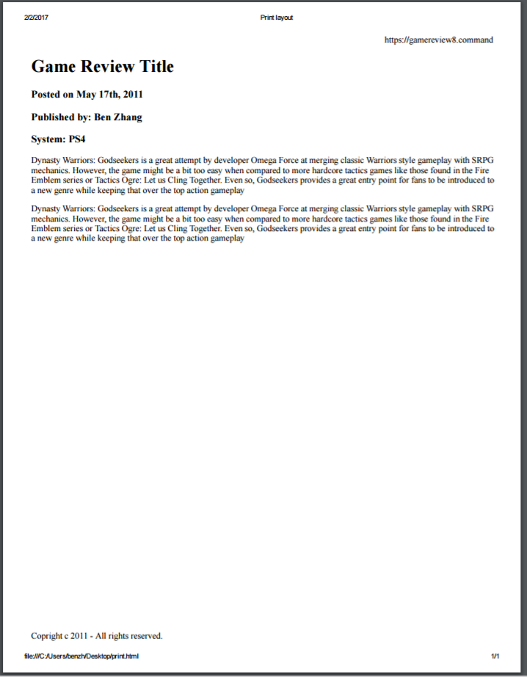

For our print layout, we removed all the image elements, including the banner, navigation bar, and the game image. The website url is printed to the top right for users to access, and the copyright claim is printed in the bottom left.

**2.3 Page design reasoning**

Our page layout will be fluid, elements will adjust its size according to the browser, because fixed-width elements may not scale well into higher resolution monitors, and we want our website to have universality. The main page is designed in a header followed by two columns layout, which allows a convenient location to put a list of upcoming games for users to access, although other pages may take a more simplistic approach.

We wanted our website to cater to young gamers, therefore we went for a modern dark background, accompanied by white text, to give the page a clean and slick look. The main page contains a large banner for the hottest review, because it will attract the attention of new comers, and invite them further for exploration. The login, sign up, and search bars are placed top right, where they will not obstruct the users view, and the design follows the convention of most websites, so experienced users can them quickly.

**3. Revised changes**

For our milestone 1, from the feedback professor Yu gave us, we have decided to scrap the idea of a built-in forum and the user’s ability to comment. We also gave the users the ability to upvote or downvote reviews, because we want to complete the core functions of the website first before expanding, and complex interactions between database and PHP may be beyond the scope of this course. However, we will implement those functions if time permits. Also, we changed our web system name to Great Reviews 8 for a smoother slogan - We rate games from 0 to GR8!

**Appendix**

**Team leader:**

Ben Zhang: A00976551

**Team members:**

Andrew Main: A00815430

Phat Le: A01012144

Simon Shoban: A00985653

Cameron Roberts: A00966003

**Game Review 8™ Game Review Web System**

**COMP 1536 Group 6**

**System Requirement Specification Document**

**Version: 1.1 Date: 01-182017**

**Table of Contents**

**1.Introduction pg.49**

1.1 Purpose pg.49

1.2 Scope pg.49

1.3 References pg.49

**2.Description pg.49**

2.1 Product Perspective pg.49

2.2 Product Functions pg.49

2.3 User Characteristics pg.50

**3. Specific Requirements pg.50**

3.1 Functions pg.50

3.2 Performance Requirements pg.50

3.3 Logical Database Requirements pg.50

3.4 Design Constraints pg.51

**4. Management Process pg.51**

4.1 Meeting Schedule pg.51

4.2 Work Assignment pg.51

4.3 Marking Rubric pg.51

4.3.1 Missing work policy pg.52

4.4 Collaboration Platform pg.52

**1.Introduction**

This Software Requirement Specification (SRS) document provides an overview of the web system. It enlists the purpose and scope of the website, descriptions of the product and function, the requirements of the system, and the management process.

**1.1 Purpose**

The purpose of the website is to create and host video game reviews. The users will be able to interact with the reviews. It will serve as a game blog and an online forum for users to view topics and upcoming game titles.

**1.2 Scope**

The goal of the website is to inform users of future game releases, as well as to provide reviewers’ opinions and recommendations for the games. In addition, the website will help to foster a healthy online community through the website forum.

The main reason for the creation of this website is because we are passionate about gaming, and want to share our ideas with the world; also, if our website is able to generate substantial traffic, we will be able to make profits from displaying advertisements.

**1.3 References**

IGN website: <http://ca.ign.com/>

Gamespot website: <http://www.gamespot.com/>

**2.Description**

The Games Review 8 web system is a website that hosts a collection of game reviews and upcoming game news. It will foster an online community by allowing users to interact with the reviews as well as signing up for an account.

**2.1 Product Perspective**

The HonestGames™ web system is similar to other web systems in the existing market. IGN and Gamespot are two of the most dominant competitors to this system; however, their scoring system is often inconsistent and influenced by sponsorship. This product will differentiate from them by offering honest reviews in a group instead.

Conversely, this system will borrow elements from their webpage architecture, such as categorizing games based on consoles, as well as including a list of popular upcoming titles on the side of the webpage.

**2.2 Product Functions**

The web system will host a category of game reviews based on the console type, each game review will be available for scoring by reviewers and users. The users will be able to view popular upcoming titles, as well as hot topics and popular reviews on the main page. The users will be able to sign up for an account. In addition, the users will be able to search for reviews based on tags reviewers has added to the review. An online forum where users can post topics and comment on other topics may also be implemented if time permits.

**2.3 User Characteristics**

The target age demographic are teenagers and adults, ranging from 13 to 40 and above. The target users are likely to spend time on the internet and are familiar with other similar web system layouts and functions. The system will design web page layout similar to other systems to allow ease of use for the experienced users.

**3. Specific Requirements**

The Game Review 8™ web system will use HTML to format the web page elements, CSS to style the webpage elements and contents, PHP for backend functions, and SQL for database management.

**3.1 Functions**

The web system will display reviews for games in a blog fashion, allowing for upvoting and downvoting at the bottom of the review. The system will host media including text, images, and videos. Text will be used to convey reviews, images and videos may be embedded in the reviews to supplement them. The system will allow account registration and deregistration. Users may create posts and reply to other posts if forum function is implemented. The system will be able to process user search inputs and return the requested information. The website layout must adhere to W3C’s guidelines.

**3.2 Performance Requirements**

The web system will be able to run on three primary browsers, Google Chrome, Internet Explorer, and Mozilla Firefox. The website will be accessible even when image and video elements are not functioning. The website will be hosted on a server and will be available to anyone at anytime and it will be HTML 5 standardized.

**3.3 Logical Database Requirements**

Game Review 8™will use SQL to store and retrieve information from databases. One database will store data such as usernames, passwords, upvotes, date of birth, age, and other member information. While the other database will store tags, titles, authors, and genresfor the article search function.

**3.4 Design Constraints**

Due to time constraints, functions such as the forum are not listed in functional requirement. If time permits they may be implemented.

**4. Management Process**

The project leader has devised a project outline describing the meeting agenda, plan for missing work, contribution mark rubric, and an idea sheet for each milestone on the google drive for members to access. The project leader is responsible for coordinating the completion of the project, which includes scheduling meetings, assigning work, taking notes of meetings, and ensuring work is done on-time. The members are responsible for attending project meetings as well as finishing their assigned work.

**4.1 Meeting Schedule**

The team is meeting two times a week, once on Wednesday and once on Saturday. Work is assigned individually the following day after the last milestone is due. We will have a mini check up mid week and a due date two days before milestone is due. The first meeting on Saturday will mostly be going over the criteria, brainstorming ideas, and assigning work for the next two weeks. The second meeting on the next Wednesday is going to be a short check-up on the progress; problems will be discussed here. The third meeting on the following Saturday will be when the assigned work is due. Members will present their work and go over any missing parts; afterwards, new assigned work and a due date will be issued to everyone. The final meeting will be on the next Wednesday. Everyone will present their final work and be evaluated based on the rubric. The leader will then compile everyone’s work and hand it in.

**4.2 Work Assignment**

Work will be assigned individually at the first meeting. Members may be further subdivided into groups of 2 or 3 to focus on specific aspects of the project. If members feel their workload is unfair it can be negotiated.

**4.3 Marking Rubric**

|  |  |  |  |  |
| --- | --- | --- | --- | --- |
|  | 1st meeting (Sat) | 2nd meeting  (Wed) | 3rd meeting  (Sat) | 4th meeting  (Wed) |
| Attendance | /1 | /1 | /1 | /1 |
| Work Completion | - | - | /3 | /3 |

This rubric will be followed strictly to avoid subjective judgment of other member’s work. As friends it might be hard to point fingers; therefore, this will help with marking and provides an easy way for us to provide members feedback at the end of the term.

Work completion is marked accordingly:

- Did not do anything : **0**

- Minimal effort (still requires other members to complete): **1**

- Unable to finish assigned portion, but has most of it done: **2**

- Finished work: **3**

The total mark will be 10 per milestone. Marks for each milestone will be tallied up at the end of the project to determine each member’s peer reviews.

**4.3.1 Missing work policy**

If any members are not able to complete their assigned work by the 4th meeting, the other members will help with their work and finish it before Friday.

**4.4 Collaboration Platform**

Members will collaborate over Google Drive, Discord and GitHub. Google Drive will be used to post documents for others to view and edit, Discord will be used to communicate between members, and GitHub